Ranada Prasad Shaha University

Department of Computer Science and Engineering



BD Walker : A Web Based Social Media Application For

Tourists

By

Md. Shehab Chowdhury

ID : 16100119

Department of Computer Science and Engineering

Supervisor

Md Montaser Hamid

Lecturer

Department of Computer Science and Engineering

Ranada Prasad Shaha University

Shitalakhya, Narayanganj - 1400, Bangladesh

January 25, 2020

# BD Walker : A Web Based Social Media Application For Tourists



A Project submitted to the

Department of Computer Science and Engineering

Ranada Prasad Shaha University

Shitalakhya, Narayanganj - 1400, Bangladesh in partial fulfillment of the requirements for the degree of

Bachelor of Science in Computer Science and Engineering

By

Md. Shehab Chowdhury

ID : 16100119

Department of Computer Science and Engineering

Supervisor

Md Montaser Hamid

Lecturer

Department of Computer Science and Engineering

January 25, 2020

# **Recommendation Letter from Project Supervisor**

The project entitled

” Developing A Social Media Web Application for Tourist ” submitted by the student

• Md. Shehab Chowdhury, 16100119

is a record of project work carried out under my supervision and I, hereby, approve that the report be submitted in partial fulfillment of the requirements for the award of their Bachelor Degrees.

Signature of the Supervisor:

Name of the Supervisor: Md Montaser Hamid

Date: January 25, 2020

# **Certificate of Acceptance of the Project**

The Project entitled

” Developing A Social Media Web Application for Tourist ” submitted by the student

• Md. Shehab Chowdhury, 16100119

on January 25, 2020 is, hereby, accepted as the partial fulfillment of the requirements for the award of their Bachelor Degrees.

Head of the Dept. Supervisor

AHM Shahriar Parvez Md Montaser Hamid

Assistant Professor & Head Lecturer

Department of Computer Science and Department of Computer Science and

Engineering Engineering

Ranada Prasad Shaha University, Ranada Prasad Shaha University,

Shitalakhya, Narayanganj - 1400, Bangladesh Shitalakhya, Narayanganj - 1400, Bangladesh

# Abstract

In this project report, I am proposing a very special social media web application for the tourist ofourcountry. Thiswebapplication notonlyhasmanyfeatureslikeothersocialmedia applications but also it has many features for the tourist which are generally not available in other social media applications. Inthisapplication, theusershallbeabletosharetheirtourexperienceandinformation in detail by creating posts so that other users shall be able to view all those important information’s about that tour. The users also shall be able to book tour offers from this application which are offered by the admin of this application.

Overall this application of mine is being developed to help the tourist to enjoy a wonderful tour in the best way possible.

Keywords: Social Media, Tourist Sites, Blog Sites, Booking Sites, Business Sites.

# Acknowledgements

I take this occasion to thank Allah, almighty for blessing me with his grace and tracking my endeavor to a successful culmination. I express my sincere thankfulness to my caring parents for guiding me all through my life, including that for my project. I would like to thank the Department of Computer Science and Engineering, Ranada Prasad Shaha University, Shitalakhya, Narayanganj-1400, Bangladesh, for supporting this project.

I would like to express my heartiest gratitude to my advisor *Md Montaser Hamid*, sir, for the constant support, and inspiration he provided me for my Bachelor Project study. His patience, motivation, supervision and vast knowledge were my thorough guide till the end.

I also want to mention another name, *Md Alif Al Amin* sir(My Co-supervisor), for his outstanding guide, support and cooperation. He is an inspiration to me. He guided me and mostly kept me motivated always. A very special thanks to him.

# Dedication

I dedicate this project to Almighty ALLAH our creator, our strong pillar, our source of inspiration, wisdom, knowledge, and understanding. He has been the source of my strength throughout this program and on His wish only have I soared. I also dedicate this work to my beloved parents who has encouraged us all the way and whose encouragement has made sure that I give it all it takes to finish that which I have started. God bless us all.

# Contents

Abstract . . . . . . . . . . . . . . . . . . . . . . . . . . . . . . . . . . . . . . . . . . I

Acknowledgement . . . . . . . . . . . . . . . . . . . . . . . . . . . . . . . . . . . . II

Dedication . . . . . . . . . . . . . . . . . . . . . . . . . . . . . . . . . . . . . . . . . III

Table of Contents . . . . . . . . . . . . . . . . . . . . . . . . . . . . . . . . . . . . . IV

List of Tables . . . . . . . . . . . . . . . . . . . . . . . . . . . . . . . . . . . . . . . VII

List of Figures . . . . . . . . . . . . . . . . . . . . . . . . . . . . . . . . . . . . . . . VIII

1. **Introduction 1**
   1. Introduction . . . . . . . . . . . . . . . . . . . . . . . . . . . . . . . . . . . . . 1
   2. Motivation . . . . . . . . . . . . . . . . . . . . . . . . . . . . . . . . . . . . . . 3
   3. Report Structure . . . . . . . . . . . . . . . . . . . . . . . . . . . . . . . . . . . 3
2. **Background Study 4**
   1. Related works . . . . . . . . . . . . . . . . . . . . . . . . . . . . . . . . . . . . 4
      1. Facebook Groups . . . . . . . . . . . . . . . . . . . . . . . . . . . . . . 4
      2. Booking Sites . . . . . . . . . . . . . . . . . . . . . . . . . . . . . . . . 5
3. **Software Requirements Specification (SRS) 6**
   1. Feasibility Studies . . . . . . . . . . . . . . . . . . . . . . . . . . . . . . . . . . 6
   2. Requirement Analysis . . . . . . . . . . . . . . . . . . . . . . . . . . . . . . . . 7
      1. Functional Requirements . . . . . . . . . . . . . . . . . . . . . . . . . . 7
      2. Non-Functional Requirements . . . . . . . . . . . . . . . . . . . . . . . 9
   3. Unified Modeling Language (UML) Diagrams . . . . . . . . . . . . . . . . . . . 10
      1. Behavioral Diagrams . . . . . . . . . . . . . . . . . . . . . . . . . . . . 10
      2. Structure Diagrams . . . . . . . . . . . . . . . . . . . . . . . . . . . . . 14
   4. Hierarchical Input Process Output (HIPO) Diagram . . . . . . . . . . . . . . . . 16
   5. Entity-Relationship(ER) Diagram . . . . . . . . . . . . . . . . . . . . . . . . . 17
   6. System Size Measurement . . . . . . . . . . . . . . . . . . . . . . . . . . . . . 18
      1. COSMIC-Function Point Analysis (FPA) . . . . . . . . . . . . . . . . . 18
4. **Methodology 22**
   1. Front-End . . . . . . . . . . . . . . . . . . . . . . . . . . . . . . . . . . . . . . 22
      1. HTML (Hyper Text Markup Language) . . . . . . . . . . . . . . . . . . 23
      2. CSS (Cascading Style Sheets) . . . . . . . . . . . . . . . . . . . . . . . 23
      3. JS (JavaScript) . . . . . . . . . . . . . . . . . . . . . . . . . . . . . . . 23
   2. Back-End . . . . . . . . . . . . . . . . . . . . . . . . . . . . . . . . . . . . . 23
      1. Node JS . . . . . . . . . . . . . . . . . . . . . . . . . . . . . . . . . . . 24
   3. Database . . . . . . . . . . . . . . . . . . . . . . . . . . . . . . . . . . . . . . . 25
      1. MongoDB . . . . . . . . . . . . . . . . . . . . . . . . . . . . . . . . . 25
   4. Server . . . . . . . . . . . . . . . . . . . . . . . . . . . . . . . . . . . . . . . . 26
   5. Version Control System (VCS) . . . . . . . . . . . . . . . . . . . . . . . . . . . 26
   6. Application Program Interface (API) . . . . . . . . . . . . . . . . . . . . . . . 27
   7. Code Editor . . . . . . . . . . . . . . . . . . . . . . . . . . . . . . . . . . . . . 27
5. **Implementation, Development, and Deployment 28**
   1. Front-End Implementation . . . . . . . . . . . . . . . . . . . . . . . . . . . . . 28
   2. Back-End Implementation . . . . . . . . . . . . . . . . . . . . . . . . . . . . . 30
      1. Express . . . . . . . . . . . . . . . . . . . . . . . . . . . . . . . . . . . 31
      2. Ejs . . . . . . . . . . . . . . . . . . . . . . . . . . . . . . . . . . . . . 31
      3. Nodemon . . . . . . . . . . . . . . . . . . . . . . . . . . . . . . . . . . 31
      4. Connect-Flash . . . . . . . . . . . . . . . . . . . . . . . . . . . . . . . 31
      5. connect-mongo, mongodb . . . . . . . . . . . . . . . . . . . . . . . . . 32
      6. Express-Session . . . . . . . . . . . . . . . . . . . . . . . . . . . . . . 32
      7. Bcryptjs . . . . . . . . . . . . . . . . . . . . . . . . . . . . . . . . . . . 32
      8. Nodemailer . . . . . . . . . . . . . . . . . . . . . . . . . . . . . . . . . 32
      9. Multer . . . . . . . . . . . . . . . . . . . . . . . . . . . . . . . . . . . . 32
      10. Babel/core, Babel/preset-env, Babel-loader, Axios, Webpack, Webpack-Cli 32
      11. Socket.io . . . . . . . . . . . . . . . . . . . . . . . . . . . . . . . . . . 32
      12. CORS, CSURF . . . . . . . . . . . . . . . . . . . . . . . . . . . . . . . 32
      13. Dotenv . . . . . . . . . . . . . . . . . . . . . . . . . . . . . . . . . . . 32
   3. Database Implementation . . . . . . . . . . . . . . . . . . . . . . . . . . . . . . 33
      1. Mongodb Atlas . . . . . . . . . . . . . . . . . . . . . . . . . . . . . . . 33
      2. Cloudinary . . . . . . . . . . . . . . . . . . . . . . . . . . . . . . . . . 34
   4. Server Implementation . . . . . . . . . . . . . . . . . . . . . . . . . . . . . . . 35
   5. Version Control System (VCS) . . . . . . . . . . . . . . . . . . . . . . . . . . . 35
   6. Logo Design . . . . . . . . . . . . . . . . . . . . . . . . . . . . . . . . . . . . . 37
   7. Features . . . . . . . . . . . . . . . . . . . . . . . . . . . . . . . . . . . . . . . 38
   8. System Testing . . . . . . . . . . . . . . . . . . . . . . . . . . . . . . . . . . . 40
      1. Authentication . . . . . . . . . . . . . . . . . . . . . . . . . . . . . . . 40
      2. Profile . . . . . . . . . . . . . . . . . . . . . . . . . . . . . . . . . . . . 52
      3. Follow or Un-Follow . . . . . . . . . . . . . . . . . . . . . . . . . . . . 53
      4. Users Post . . . . . . . . . . . . . . . . . . . . . . . . . . . . . . . . . 55
      5. Search . . . . . . . . . . . . . . . . . . . . . . . . . . . . . . . . . . . . 60
      6. Chat . . . . . . . . . . . . . . . . . . . . . . . . . . . . . . . . . . . . . 61
      7. Announcement . . . . . . . . . . . . . . . . . . . . . . . . . . . . . . . 62
      8. Offer . . . . . . . . . . . . . . . . . . . . . . . . . . . . . . . . . . . . 64
      9. Guide . . . . . . . . . . . . . . . . . . . . . . . . . . . . . . . . . . . . 67
      10. Account . . . . . . . . . . . . . . . . . . . . . . . . . . . . . . . . . . . 70
      11. Feedback . . . . . . . . . . . . . . . . . . . . . . . . . . . . . . . . . . 72
      12. Contact Us . . . . . . . . . . . . . . . . . . . . . . . . . . . . . . . . . 73
      13. About . . . . . . . . . . . . . . . . . . . . . . . . . . . . . . . . . . . . 74
   9. Limitations . . . . . . . . . . . . . . . . . . . . . . . . . . . . . . . . . . . . . 75
   10. Alpha Testing & Bug Fixing . . . . . . . . . . . . . . . . . . . . . . . . . . . . 75
   11. User’s Feedback & Requirements . . . . . . . . . . . . . . . . . . . . . . . . . 76
6. **Future Work 77**

List of Tables

4.1 Importance of MongoDB . . . . . . . . . . . . . . . . . . . . . . . . . . . . . . 26

# List of Figures

|  |  |  |
| --- | --- | --- |
| 1.1 | Some important features of bd walker . . . . . . . . . . . . . . . . . . . . . . . | 2 |
| 2.1 | Travelers of Bangladesh(Facebook Group) . . . . . . . . . . . . . . . . . . . . . | 5 |
| 2.2 | Best Tourist Spots Review & Booking Site . . . . . . . . . . . . . . . . . . . . . | 5 |
| 3.1 | The Use Case diagram of bd walker for registered user & non-registered user . . | 11 |
| 3.2 | The Use Case diagram of bd walker for admin . . . . . . . . . . . . . . . . . . . | 12 |
| 3.3 | The Activity diagram of bd walker . . . . . . . . . . . . . . . . . . . . . . . . . | 13 |
| 3.4 | The Class diagram of bd walker . . . . . . . . . . . . . . . . . . . . . . . . . . | 15 |
| 3.5 | The Hierarchical Input Process Output (HIPO) diagram of bd walker . . . . . . | 16 |
| 3.6 | The Entity-Relationship (ER) diagram of bd walker . . . . . . . . . . . . . . . . | 17 |
| 5.1 | Mobile view of bd walker . . . . . . . . . . . . . . . . . . . . . . . . . . . . . . | 28 |
| 5.2 | Tablet view of bd walker . . . . . . . . . . . . . . . . . . . . . . . . . . . . . . | 29 |
| 5.3 | Desktop view of bd walker . . . . . . . . . . . . . . . . . . . . . . . . . . . . . | 29 |
| 5.4 | Dashboard of my Mongodb-Atlas account . . . . . . . . . . . . . . . . . . . . . | 33 |
| 5.5 | Dashboard of my Cloudinary account . . . . . . . . . . . . . . . . . . . . . . . | 34 |
| 5.6 | Dashboard of my Heroku account . . . . . . . . . . . . . . . . . . . . . . . . . | 35 |
| 5.7 | First commit on my GitHub repository for bd walker . . . . . . . . . . . . . . . | 36 |
| 5.8 | Last commit on my GitHub repository for bd walke . . . . . . . . . . . . . . . . | 36 |
| 5.9 | BD Walker logo 1 . . . . . . . . . . . . . . . . . . . . . . . . . . . . . . . . . . | 37 |
| 5.10 BD Walker logo 2 . . . . . . . . . . . . . . . . . . . . . . . . . . . . . . . . . . | | 37 |
| 5.11 BD Walker logo 3 . . . . . . . . . . . . . . . . . . . . . . . . . . . . . . . . . . | | 37 |
| 5.12 Testing live validation . . . . . . . . . . . . . . . . . . . . . . . . . . . . . . . | | 40 |

|  |  |
| --- | --- |
| 5.13 Sign-Up form fill up. . . . . . . . . . . . . . . . . . . . . . . . . . . . . . . . . | 41 |
| 5.14 Sign-up Form Submitted Successfully . . . . . . . . . . . . . . . . . . . . . . . | 41 |
| 5.15 Getting email with verification code . . . . . . . . . . . . . . . . . . . . . . . . | 42 |
| 5.16 Entering wrong verification code . . . . . . . . . . . . . . . . . . . . . . . . . . | 42 |
| 5.17 Getting errors for wrong verification code . . . . . . . . . . . . . . . . . . . . . | 43 |
| 5.18 Entering correct verification code . . . . . . . . . . . . . . . . . . . . . . . . . | 43 |
| 5.19 Sign-Up successfully completed . . . . . . . . . . . . . . . . . . . . . . . . . . | 44 |
| 5.20 Getting errors for invalid username/password . . . . . . . . . . . . . . . . . . . | 45 |
| 5.21 Entering correct username & password (User Login) . . . . . . . . . . . . . . . | 45 |
| 5.22 User-Dashboard . . . . . . . . . . . . . . . . . . . . . . . . . . . . . . . . . . . | 46 |
| 5.23 Entering correct username & password (Admin Login) . . . . . . . . . . . . . . | 46 |
| 5.24 Admin-Dashboard . . . . . . . . . . . . . . . . . . . . . . . . . . . . . . . . . . | 47 |
| 5.25 Requesting for password reset . . . . . . . . . . . . . . . . . . . . . . . . . . . | 47 |
| 5.26 Entering invalid email . . . . . . . . . . . . . . . . . . . . . . . . . . . . . . . . | 48 |
| 5.27 Getting errors for invalid email . . . . . . . . . . . . . . . . . . . . . . . . . . . | 48 |
| 5.28 Entering valid email . . . . . . . . . . . . . . . . . . . . . . . . . . . . . . . . . | 49 |
| 5.29 Sending user verification code . . . . . . . . . . . . . . . . . . . . . . . . . . . | 49 |
| 5.30 Getting email with user verification code . . . . . . . . . . . . . . . . . . . . . . | 50 |
| 5.31 Entering correct user verification code . . . . . . . . . . . . . . . . . . . . . . . | 50 |
| 5.32 Entering new password . . . . . . . . . . . . . . . . . . . . . . . . . . . . . . . | 51 |
| 5.33 Password successfully updated . . . . . . . . . . . . . . . . . . . . . . . . . . . | 51 |
| 5.34 Profile picture updating . . . . . . . . . . . . . . . . . . . . . . . . . . . . . . . | 52 |
| 5.35 Profile picture successfully updated . . . . . . . . . . . . . . . . . . . . . . . . | 52 |
| 5.36 Password successfully updated . . . . . . . . . . . . . . . . . . . . . . . . . . . | 53 |
| 5.37 Trying to follow a user . . . . . . . . . . . . . . . . . . . . . . . . . . . . . . . | 53 |
| 5.38 Successfully followed a user . . . . . . . . . . . . . . . . . . . . . . . . . . . . | 54 |
| 5.39 Successfully un-followed a user . . . . . . . . . . . . . . . . . . . . . . . . . . | 54 |
| 5.40 Creating a post with Google-Place-Suggestion API . . . . . . . . . . . . . . . . | 55 |
| 5.41 Creating a post with CK-Editor API . . . . . . . . . . . . . . . . . . . . . . . . | 55 |
| 5.42 Viewed a post successfully . . . . . . . . . . . . . . . . . . . . . . . . . . . . . | 56 |

|  |  |
| --- | --- |
| 5.43 Modified a post successfully . . . . . . . . . . . . . . . . . . . . . . . . . . . . | 56 |
| 5.44 Viewed others post successfully . . . . . . . . . . . . . . . . . . . . . . . . . . | 57 |
| 5.45 Added love-react on a post Successfully . . . . . . . . . . . . . . . . . . . . . . | 57 |
| 5.46 Removed love-react from a post successfully . . . . . . . . . . . . . . . . . . . | 58 |
| 5.47 Added a comment on a post successfully . . . . . . . . . . . . . . . . . . . . . | 58 |
| 5.48 Removed a comment from a post successfully . . . . . . . . . . . . . . . . . . . | 59 |
| 5.49 Reported on a post successfully . . . . . . . . . . . . . . . . . . . . . . . . . . | 59 |
| 5.50 Post founded successfully . . . . . . . . . . . . . . . . . . . . . . . . . . . . . | 60 |
| 5.51 Chatting feature is working well (1) . . . . . . . . . . . . . . . . . . . . . . . . | 61 |
| 5.52 Chatting feature is working well (2) . . . . . . . . . . . . . . . . . . . . . . . . | 61 |
| 5.53 Creating an announcement by admin successfully . . . . . . . . . . . . . . . . . | 62 |
| 5.54 Viewing an announcement by admin successfully . . . . . . . . . . . . . . . . . | 62 |
| 5.55 Modified an announcement by admin successfully . . . . . . . . . . . . . . . . . | 63 |
| 5.56 Viewing an announcement by user successfully . . . . . . . . . . . . . . . . . . | 63 |
| 5.57 Creating an offer by admin . . . . . . . . . . . . . . . . . . . . . . . . . . . . . | 64 |
| 5.58 viewing an offer by admin successfully . . . . . . . . . . . . . . . . . . . . . . | 64 |
| 5.59 Viewing an offer by user successfully . . . . . . . . . . . . . . . . . . . . . . . | 65 |
| 5.60 Booking an offer . . . . . . . . . . . . . . . . . . . . . . . . . . . . . . . . . . | 65 |
| 5.61 Booked an offer successfully . . . . . . . . . . . . . . . . . . . . . . . . . . . . | 66 |
| 5.62 Booking Information . . . . . . . . . . . . . . . . . . . . . . . . . . . . . . . . | 66 |
| 5.63 Creating A Guide . . . . . . . . . . . . . . . . . . . . . . . . . . . . . . . . . . | 67 |
| 5.64 Viewing a guide by admin successfully . . . . . . . . . . . . . . . . . . . . . . . | 68 |
| 5.65 Viewing a guide by user successfully . . . . . . . . . . . . . . . . . . . . . . . . | 69 |
| 5.66 Ban a user . . . . . . . . . . . . . . . . . . . . . . . . . . . . . . . . . . . . . . | 70 |
| 5.67 User banned successfully . . . . . . . . . . . . . . . . . . . . . . . . . . . . . . | 71 |
| 5.68 Sending Feedback . . . . . . . . . . . . . . . . . . . . . . . . . . . . . . . . . . | 72 |
| 5.69 Contact-Us . . . . . . . . . . . . . . . . . . . . . . . . . . . . . . . . . . . . . | 73 |
| 5.70 Getting email from guest successfully . . . . . . . . . . . . . . . . . . . . . . . | 73 |
| 5.71 Email from bd walker . . . . . . . . . . . . . . . . . . . . . . . . . . . . . . . . | 74 |
| 5.72 About-Me . . . . . . . . . . . . . . . . . . . . . . . . . . . . . . . . . . . . . . | 74 |

5.73 Bug Fixed ( Through The Alpha Test ) . . . . . . . . . . . . . . . . . . . . . . . 75

Chapter 1

# Introduction

## 1.1 Introduction

Bangladesh has a lot of tourist spots but the people of our country may or may not has the proper information about those tourist spots, such as how to go?, When is the right time to visit? how much cost did we need to visit? which places are risky but wonderful for a visit? etc. We all know that, if we don’t have any idea about that information, we won’t be able to make our tour perfect, but if we get all of that information, We can make our tour most wonderful.

Forthispurpose, ImadeasocialmediawebapplicationfortouristandInamedit**’BDWALKER’**. BDwalker can be accessed from any type of platform which supported a web browser. it has a lot of features and it is more than a social media web application because bdwalker not only has many features like other social media applications, *[ such as: chatting, following and so more..! ]* but also it has many features for tourist *[ such as: creating tour related posts, booking tour offers, Exploring new tourist places, getting tourist guides information and so more..! ]* which are generally not available in other social media applications. In bdwalker users shall get a lot of information about tourist spots, tourist guides, and exciting tour offers which are provided by the admin of bdwalker.

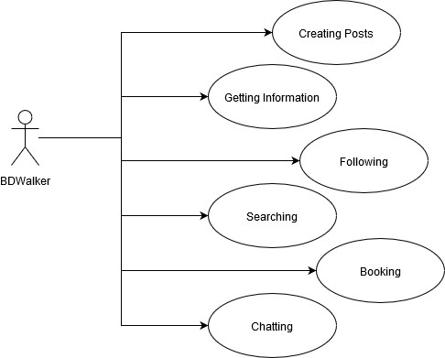

Figure 1.1: Some important features of bd walker

By using bdwalker, the user shall be able to share their experience & provide information in detail of his/her visited tourist spots via creating posts so that other users be able to views that posts and make their tour more easier, enjoyable, inexpensively and perfect. They can also give likes & comments on other user’s posts. The user shall be able to find out existing posts by searching, they also shall be able to follow each other so that they can get all the existing posts from the following users. The user shall be able to communicate with others through chat. They can also able to booking tourist offers as well as through bdwalker.

One the other hand bdwalker has an admin section. In this section admin can perform several tasks like managing user’s account & posts, creating announcements, adding and modifying tourist offers & guides for the users.

BDwalker is not only a social media web application, but it is also an important, useful & powerful web application for both tourists and tourism of our country.

## 1.2 Motivation

Nowadays, In our country, lots of people are crazy about tourists and tourism. There are many webapplicationsavailableontheinternetforsocialmedia, blogsites, tourist-tourismbusinesssites, booking sites, etc. But there is no batter web applications are available for tourist and tourism, in order that they can find the proper and newest information about tourist spots.

Now it has become really necessary to build a web application in order to provide each and every latest information about tourist spots. That’s why I take a decision to build a social media web application for the tourist & tourism of our country with tourist information and business planning.

## 1.3 Report Structure

The rest of the chapters is structured as follows:

* Chapter 2 reviews some of the related works on other web applications.
* Software Requirements Specification(SRS) of my project will be found in chapter 3.
* Chapter 4 outlines the methodology for my project work in detail.
* Chapter 5 outlines the implementation, deploy and development of the project. it discusses in detail how I have been implemented and how much work has been done so for.
* Future work and discussions based on the construction and user feedback of my project will be found in chapter 6.

Chapter 2

# Background Study

## 2.1 Related works

A few works are available on the web which is related to tourist & tourism.

1. Facebook Groups
2. Tourist Spots Review & Booking Sites

### 2.1.1 Facebook Groups

we are in 2020 right now and I think that we all are familiar with **FACEBOOK**. Now the matter is that Facebook has a number of groups which are based on the tourist of our country and the most popular group name is **Travelers of Bangladesh(TOB)**. This group is so much popular in our country and it has around 1,017,652 [Accessed on 16 January 2020] members right now.

In this Facebook, group users love to share their tourist experience and highlight so that other users shall be able to make their tour batter and inexpensive [1].

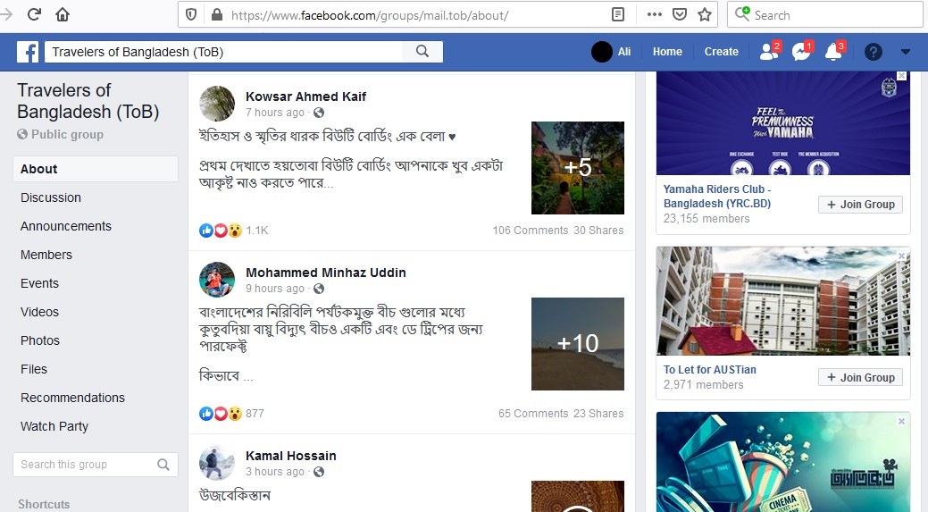

Figure 2.1: Travelers of Bangladesh(Facebook Group)

NOTE: One day this group could be ban or invisible in order to facebook policy.

### 2.1.2 Booking Sites

Therearelotsofbusinesssitesavailableonthewebforthetourist. Butthis([https://nijhoom. com](https://nijhoom.com/)) is the best website for booking offers of tourist spots as well. This website also provides information about tourist places in & spots. This website has a few important features like Travel Blog, Holiday Packages, Car Rant and so more. Visit this website for more information. [2].

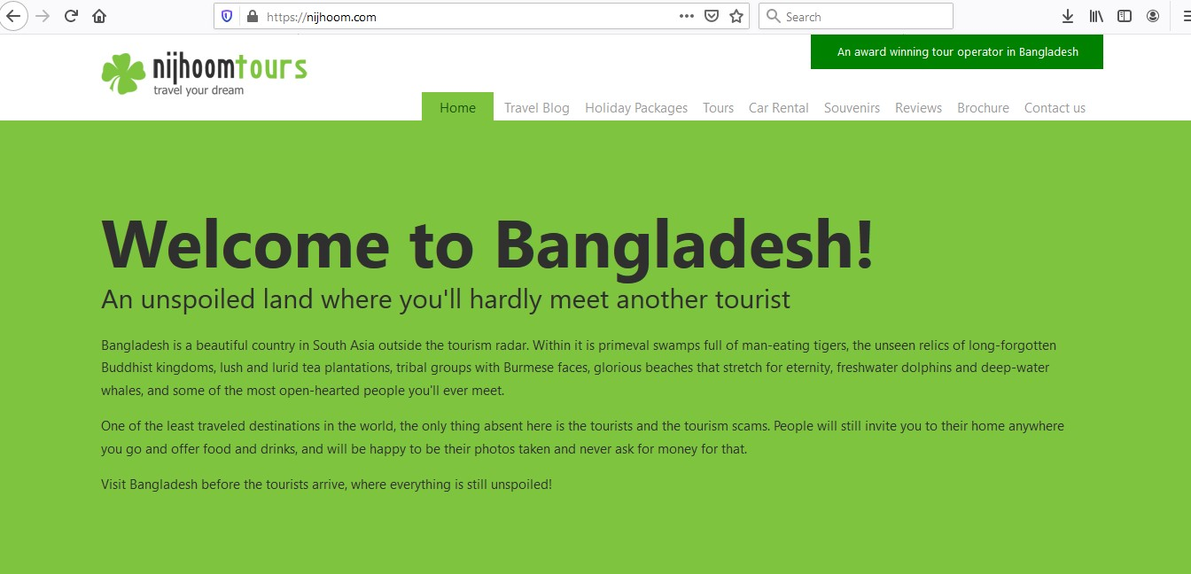

Figure 2.2: Best Tourist Spots Review & Booking Site

Chapter 3

Software Requirements Specification

# (SRS)

## 3.1 Feasibility Studies

Before building my project, I verified my project with all types of feasibility studies.

Project’s feasibility studies are given below:

1. Technical feasibility
   1. Facility to produce outputs in a given times
   2. Response time under certain conditions.
   3. Ability to process certain transactions at a given speed.
   4. Facility to communicate data to distant locations.
2. Operational feasibility
   1. Helpful & Useful for the human being
   2. Easy to use and no new skills are required if users are familiar with other web applica-

tions.

* 1. Can be accessed from any type of platform.

1. Economic feasibility
   1. Project’s investment costs will be less than the benefits.
2. Legal feasibility
   1. Conflicts with legal requirements like zoning laws, data protection acts or social media laws.
3. Scheduling feasibility
   1. Within 4 months or 121 days this project will be able to release as **Alpha Version**.

## 3.2 Requirement Analysis

There are two types of requirements we would denote:

1. Functional Requirements
2. Non-Functional Requirements

### 3.2.1 Functional Requirements

Functional Requirements of our system are :

1. The user shall be able to browse through as a **Guest/Non-Registered User**.
2. The user shall be able to login to modify his/her account as a **Registered User**.
3. **As a Non-Registered User**
   1. The user shall be able to **Create an account on ’BDWALKER’**.
   2. The user shall be able to **Browse/View the Top 7 tourist places to visit in Bangladesh**.
   3. The user shall be able to **Contact with us via Email**.
   4. The user shall be able to **View About-Me**.
4. **As a Registered User**
   1. The user shall be able to log in as a **User**.
   2. The user shall be able to log in as a **Admin**.

**(a) As a User**

i. The user shall be able to **CRUD his/her posts.** ii. The user shall be able to **View others post.**

iii. The user shall be able to **Add/Remove ‘Love React’ & ‘comments’ on a post.** iv. The user shall be able to **Report on a post.**

v. The user shall be able to **Follow/UnFollow others.** vi. The user shall be able to **Search his/her or others post.**

vii. The user shall be able to **Chat with others.** viii. The user shall be able to **View/Modify his/her profile.** ix. The user shall be able to **Modify his/her account**

1. The user shall be able to **View others profile.**
2. The user shall be able to **View/Booking Admin’s Tourist Offers.** xii. The user shall be able to **View Admin’s Announcements.** xiii. The user shall be able to **View Tourist Guides with their information.** xiv. Theusershallbeableto**Browse/ViewtheTop7touristplacestovisitinBangladesh.** xv. The user shall be able to **Report Issues.** xvi. The user shall be able to **Give Feedback.** xvii. The user shall be able to **View About-Me.**

**(b) As an Admin**

i. The user shall be able to **CRUD his/her ’Announcements’.** ii. The user shall be able to **CRUD his/her ‘Tourist Offers’.** iii. The user shall be able to **CRUD his/her ’Tourist Guides’.** iv. The user shall be able to **View User’s Information.**

v. The user shall be able to **Ban/Active User’s Account.** vi. The user shall be able to **View/Delete User’s post.** vii. The user shall be able to **Remove ‘comments’ from User’s post.**

3.2.2 Non-Functional Requirements Non-Functional Requirements of our system are :

1. **Performance**: The system shall load faster.
2. **Capacity**: The system shall be able to handle 1000 requests per instance.
3. **Availability**: The system shall be available 20 hours per day.
4. **Maintainability**: The system shall be closed 150 hours per month for maintenance and

elaboration.

1. **Security**: The system should encrypt user passwords using the AES-256 Encryption System.
2. **Reliability**: The system shall never crash more than 10 minutes per month.
3. **Usability**: The users should be able to learn how to use the system at most 2 hours.
4. **Scalability**: The system should run smoothly in most devices that support a web browser.

## 3.3 Unified Modeling Language (UML) Diagrams

There are two types of UML Diagram :

1. Behavioral Diagrams
2. Structure Diagrams

### 3.3.1 Behavioral Diagrams

UML has many types of Behavioral Diagrams,but I will consider only two of them :

1. Use-Case Diagram
2. Activity Diagram

3.3.1.1 Use-Case Diagram

In my project there are 3 types of actors are present.

1. Non-Registered User
2. Registered User
3. Admin

Use Case Diagram for **registered user & non-registered user** is given below :

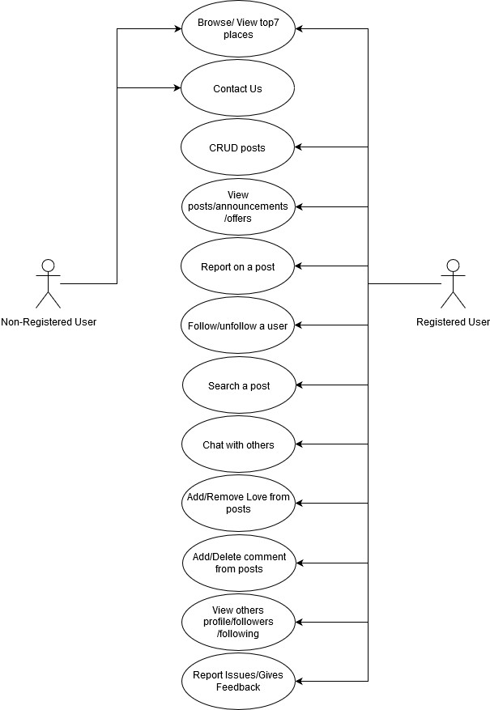

Figure 3.1: The Use Case diagram of bd walker for registered user & non-registered user Use Case Diagram for **admin** is given below :

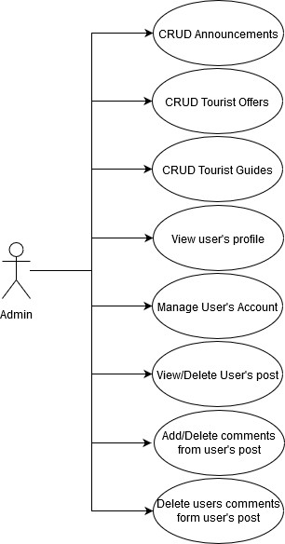

Figure 3.2: The Use Case diagram of bd walker for admin

3.3.1.2 Activity Diagram

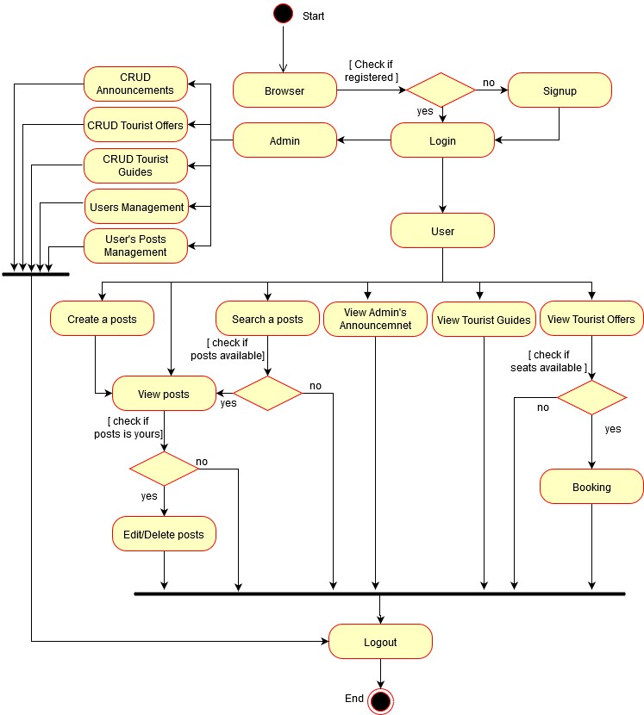

Figure 3.3: The Activity diagram of bd walker

### 3.3.2 Structure Diagrams

UML has many types of Structure Diagrams, but I will consider only one of them :

1. Class Diagram

3.3.2.1 Class Diagram

The Class Diagram of my project is given on the next page.

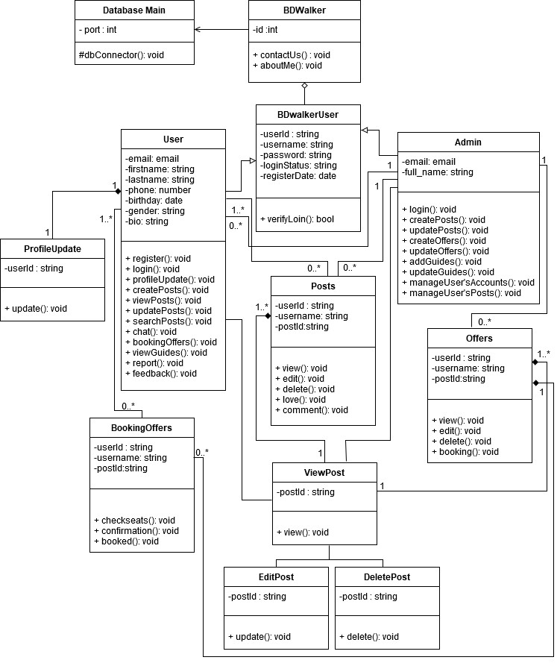

Figure 3.4: The Class diagram of bd walker

## 3.4 Hierarchical Input Process Output (HIPO) Diagram

The HIPO diagram of my system is given below :

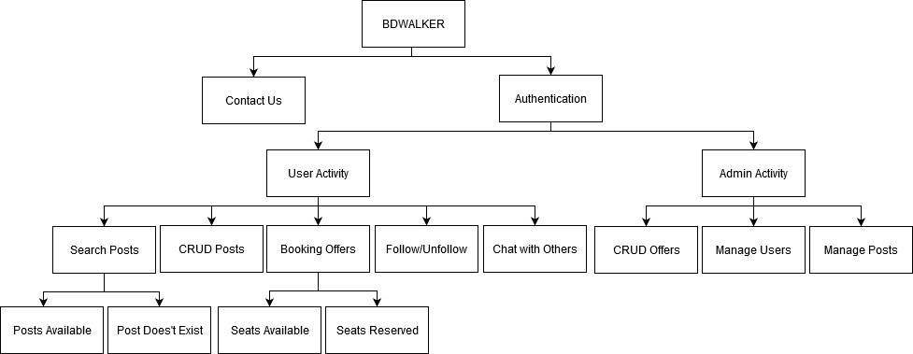

Figure 3.5: The Hierarchical Input Process Output (HIPO) diagram of bd walker

## 3.5 Entity-Relationship(ER) Diagram

The Entity Relationship Diagram of my project is given below :

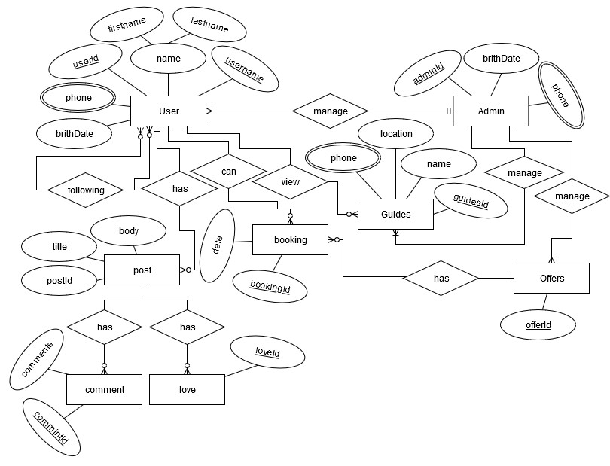

Figure 3.6: The Entity-Relationship (ER) diagram of bd walker

## 3.6 System Size Measurement

### 3.6.1 COSMIC-Function Point Analysis (FPA)

**Identifying Functional User Requirements (FUR):**

* FUR-1: The user shall be able to Register for an account.
  1. E - Enter registration details
  2. W- Give Information
  3. X - Get Confirmation
  4. X - Error Message

Size of **FUR-1 = 4**

* FUR-2: The user shall be able to Login to His/Her Account.
  1. E - Enter login details
  2. X - Get Confirmation
  3. X - Error Message

Size of **FUR-2 = 3**

* FUR-3: The user shall be able to Contact with us.
  1. E - Enter Contact details
  2. W- Give Information
  3. X - Error Message

Size of **FUR-3 = 3**

* FUR-4: The user shall be able to View About-Me.
  1. E - Enter About-ME details
  2. R - Get Information
  3. X - Error Message Size of **FUR-4 = 3**

FUR-5: The user shall be able to Give Feedback/Report Issue.

1. E - Enter identity details
2. E - Enter feedback/report
3. X - Error Message

Size of **FUR-5 = 3**

* FUR-6: The user shall be able to Modify accounts.
  1. E - Enter account details
  2. W - Modify account
  3. X - Get confirmation
  4. X - Error Message

Size of **FUR-6 = 4**

* FUR-7: The user shall be able to Add/Modify/Delete Posts/Offers/Announcements.
  1. E - Enter panel
  2. R - Get list of components
  3. W - Confirm necessary add/modify/delete operation
  4. X - Get confirmation
  5. X - Error Message

Size of **FUR-7 = 5**

* FUR-8: The user shall be able to View Posts/Offers/Announcements.
  1. E - Enter panel
  2. R - Get list of components
  3. X - Get confirmation
  4. X - Error Message Size of **FUR-8 = 4** FUR-9: The user shall be able to Follow others.
  5. E - Enter User details
  6. W - Sent Follow request
  7. X - Get confirmation
  8. X - Error Message

Size of **FUR-9 = 4**

* FUR-10: The user shall be able to Search Posts.
  1. E - Enter Search details
  2. W - Give Components
  3. R - Get list of components
  4. X - Error Message

Size of **FUR-10 = 4**

* FUR-11: The user shall be able to Booking Offers.
  1. E - Enter Booking details
  2. W - Request for Booking
  3. R - Get Confirmation
  4. X - Error Message

Size of **FUR-11 = 4**

* FUR-12: The user shall be able to Add/Delete comments from posts.
  1. E - Enter Post details
  2. W - Confirm necessary add/delete operation
  3. R - Get Confirmation
  4. X - Error Message Size of **FUR-12 = 4** FUR-13: The user shall be able to Add/Remove love react from posts.
  5. E - Enter Post details
  6. W - Confirm necessary add/remove operation
  7. X - Error Message Size of **FUR-13 = 3**

*Size of the system:* **CFP**

Chapter 4

# Methodology

I am a Linux(OS) user. Linux is an open-source operating system that is the foundation for the stack model. I built my project on Linux as **’A Full Stack Development’**. Full Stack Development consists of some major components.

1. Front-End
2. Back-End
3. Database
4. Server
5. Version Control System (VCS)
6. Working with Application Program Interface (API)

## 4.1 Front-End

Front-end is everything that a user can see and interact on a website. For example The text, videos and also Images. Every single website that we see on the internet today all must have three languages & They are:

1. HTML (Hyper Text Markup Language)
2. CSS (Cascading Style Sheets)
3. JS (JavaScript)

### 4.1.1 HTML (Hyper Text Markup Language)

The full form of HTML is **Hyper Text Markup Language**. It is a **markup language** for creating a webpage. By using HTML we can mark and describe some kinds of content like writing, links, pictures, and even sound and video on webpage and webpages are usually viewed in a web browser so that the browser can display them correctly. ’HTML5’ is the latest version of HTML.

### 4.1.2 CSS (Cascading Style Sheets)

ThefullformofCSSis**CascadingStyleSheets**.ThefirstCSSreleasedasanofficialW3C(World

Wide Web Consortium) on December 17, 1996. So, first officially CSS created by Hakon Wium Lie and Bert Bos (developed Argo web browser) [3]. It gives HTML elements styles and describes how HTML elements are to be displayed.

On the other hand, Bootstrap is also used to give styles to HTML elements. Bootstrap is nothing but the most popular CSS framework for developing responsive and mobile-first websites.’ Bootstrap 4’ is the latest version of Bootstrap [4].

### 4.1.3 JS (JavaScript)

JS, full form is **JavaScript**. It is the **Programming Language** for the Web. It can manipulate, calculate and validate data. It also can update and change both **HTML** and **CSS**. To build the Front-end of my project, I also used **HTML**, **CSS**( included Bootstrap 4 ) and **JS**.

## 4.2 Back-End

Everything behind that scene that powers the website is known as Back-end of a website. The back-end is the power of users consist and we use Programming Language like **’PHP’** and **’Node JS’** to help us to write the functionalities that handle business logic such as Browsing Products,

Place a Bookings, Receive Orders, Accept Payments, etc.

To build the Back-end of my project, I used **’Node JS’**.

### 4.2.1 Node JS

NodeJs is a **JavaScript** based framework. It is developed by *Ryan Dahl*in 2009. It is released under the Massachusetts Institute of Technology (**MIT**) license. It is an open-source & completely

free.

Nodejs is a JavaScript runtime environment & it is built on google chrome’s JavaScript V8 engine. It is lightweight and efficient [5].

Features of NodeJs :

* Event Driven
* Single Threaded
* Asynchronous
* No Buffering

Nodejs runs on various platforms like Windows, Linux, Mac, etc. It’s can generate the dynamic page content. It can create, open, read, write, delete and close files on the server. It can collect form data. It can add, delete, modify data in a database. Nodejs has a Package Manager called **NPM**.

4.2.1.1 Node Package Manager (NPM)

NPM is the world’s largest software registry (library).The registry contains over 800,000 code packages and all are free to use.All npm packages are defined in files called **package.json**. The content of package.json must be written in **JSON** [6] .

I used **more than 28** code packages from NPM in my project.

4.2.1.2 Express Js

I also used **Express Js** in my project. Express Js is nothing but a web application framework for

Nodejs. It is developed by *Tj Holowaychik* in November 2010. It is free & open-source software. It is licensed under the Massachusetts Institute of Technology (**MIT**).

ExpressJs has facilitated rapid development. It allows us to set up middleware to respond to HTTP requests. It is also allowed to dynamically render HTML pages.

## 4.3 Database

Database is a place in which our data is stored.

There are two types of databases:

1. Relational Databases (Example: Microsoft SQL Server, My SQL, etc)
2. Non-Relational Databases (Example: MongoDB, Firebase, etc)

To build my project, I used A Non-Relational Database named **’MongoDB’**.

### 4.3.1 MongoDB

MongoDB is a non-relational database which stores data as documents in a binary representation called **BSON** (Binary **JSON**). It stores related information together for fast query assess through the MongoDB query language.

MongoDB is also called No SQL database, No SQL is known as Not Only SQL database. It provides a mechanism for storage and retrieval of data and is the next generation of databases. It has no specific schema and can handle a huge amount of data [7].

Table 4.1: Importance of MongoDB

|  |  |
| --- | --- |
| Name | MongoDB |
| Database Type | Non-Relational Database. |
| Language | It has Unstructured Query Language. |
| Schema | It has Dynamic Schema |
| Scalability | It is Horizontally Scalable |
| comparison | It is faster than My SQL |

## 4.4 Server

The server is a place to host our web application so that other users can run from and use my web application. It is a machine or computer program that provides functionality or data for other machines or programs. Servers are the lifeblood of any network. They provide the shared resource that the network users need such as web service.

For my project hosting, I used **’Heroku’**. Heroku is nothing but a cloud app program that lets us build applications in almost any language. We can deploy our web application free on Heroku via ’Heroku Git’ or ’GitHub’ [8].

## 4.5 Version Control System (VCS)

Version Control System is a system that records the changes made to the application files over time so that specific versions can be recalled later if required.

**’GitHub’** is the best for the Version Control System (VCS) because it is a code hosting platform for collaboration and version control.

For my project, I used ’GitHub’ as well as for the project’s code storing & version controlling

[9].

## 4.6 Application Program Interface (API)

API is an application program interface that allows us to use third-party or other applications in our web application. Types of APIs:

* SOAP
* XML-RPC
* JSON-RPC
* REST

I used more than 3 APIs on my project work.

## 4.7 Code Editor

A code editor is a place where programmers spend most of their time. I used **’Visual Studio** (VS) **Code’** as my code editor during developing my project. VS Code is a Microsoft-powered platform for developers. It is an open-source platform and can be used on any major platform. VS code is very lightweight and does not consume much of the RAM and promotes fast access and implementation [10] .

Chapter 5

# Implementation, Development, and Deployment

## 5.1 Front-End Implementation

I used **HTML**, **CSS**, **JS** and **Bootstrap 4** to implement my project’s ’Front-End’. My project’s ’Front-End’ is built with responsive design. The goal of responsive design is to build web pages that detect the visitor’s screen size and orientation and change the layout accordingly. I also used icons from **Font-Awesome (CDN)** [11] .

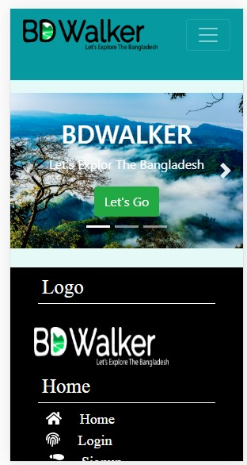

Figure 5.1: Mobile view of bd walker

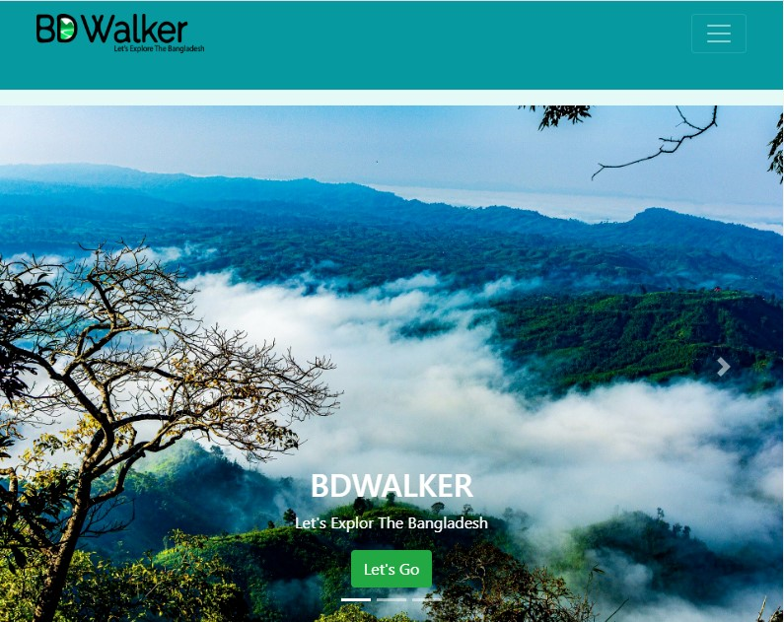

Figure 5.2: Tablet view of bd walker

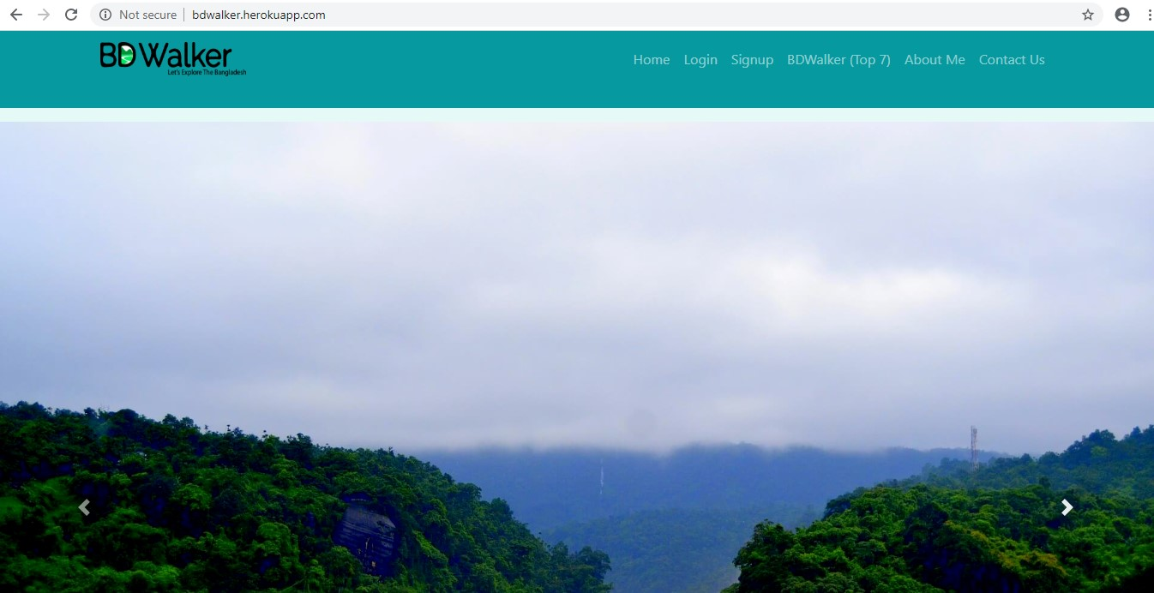

Figure 5.3: Desktop view of bd walker

## 5.2 Back-End Implementation

I used **Node JS** to implement my project’s ’Back-End’. Nodejs has a Package Manager called

**NPM** and used **more than 28** code packages from it, to build my project [6] .

Used NPM code packages are given below :

1. express: v.4.16.4,
2. ejs: v.2.6.1,
3. nodemon: v.1.19.0,
4. connect-flash: v.0.1.1,
5. connect-mongo: v.3.0.0,
6. mongodb: v.3.2.6,
7. validator: v.11.0.0,
8. express-session: v.1.16.1,
9. md5: v.2.2.1,
10. bcryptjs: v.2.4.3,
11. nodemailer: v.6.4.2,
12. randomstring: v.1.1.5,
13. multer: v.1.4.2,
14. googleplaces: v.0.6.1,
15. cloudinary: v.1.18.1,
16. sanitize-html: v.1.20.1,
17. jsonwebtoken: v.8.5.1,
18. babel/core: v.7.4.5,
19. babel/preset-env: v.7.4.5,
20. babel-loader: v.8.0.6,
21. axios: v.0.19.0,
22. webpack: v.4.34.0,
23. webpack-cli: v.3.3.4
24. socket.io: v.2.2.0,
25. dompurify: v.1.0.10,
26. cors: v.2.8.5,
27. csurf: v.1.10.0,
28. dotenv: v.8.0.0,

5.2.1 Express

Express has been used for rapid development, middle-ware setups, and handling routers.

5.2.2 Ejs

EJS has been used to set up the view engine.

### 5.2.3 Nodemon

Nodemon has been used for automatically restarting the node application when file changes in the directory are detected.

5.2.4 Connect-Flash

Connect-Flash has been used for storing and displaying messages.

### 5.2.5 connect-mongo, mongodb

connect-mongo and MongoDB has been used to make a connection between nodejs(Back-End) and MongoDB(Database)

5.2.6 Express-Session

express-session has been used to store and manage cookies.

5.2.7 Bcryptjs

Bcryptjs has been used to do password hashing.

5.2.8 Nodemailer

Nodemailer has been used to do send emails.

5.2.9 Multer

has been used to upload files.

5.2.10 Babel/core, Babel/preset-env, Babel-loader, Axios, Webpack, Webpack-Cli

have been used to build a Search option.

5.2.11 Socket.io

has been used to build a Chat option.

5.2.12 CORS, CSURF

have been used to protect my web application from malicious attacks.

### 5.2.13 Dotenv

has been used to storing configuration in the environment separate from code is based on The

Twelve-Factor App methodology.

## 5.3 Database Implementation

In my project, I have been implemented Database through two sectors.

1. Mongodb Atlas (Textual Data)
2. Cloudinary (Files)

MongoDB Atlas is a fully managed cloud database service built by the official MongoDB team

[12].

On the other hand, Cloudinary is a cloud-based image and video management services by SaaS technology company [13].

### 5.3.1 Mongodb Atlas

I make a connection between ’Mongodb Atlas’ and ’Node Js’ through using 2 code packages ( connect-mongo, MongoDB ) from NPM so that I can store the user’s textual data.

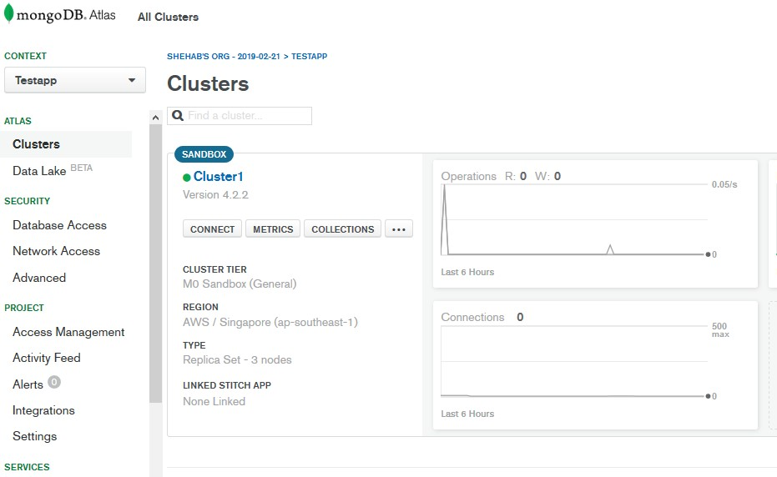

Figure 5.4: Dashboard of my Mongodb-Atlas account

### 5.3.2 Cloudinary

I make another connection between ’Cloudinary’ and ’Node Js’ through using cloudinary code packages from NPM and cloudinary API so that I can store user files.

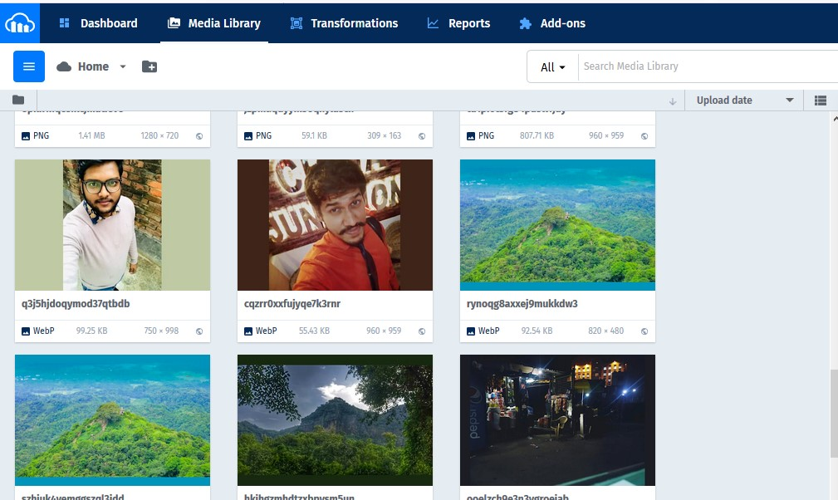

Figure 5.5: Dashboard of my Cloudinary account

## 5.4 Server Implementation

I used **Heroku** for my project hosting. Heroku is free and easy to use for hosting so I set up my project on it.

My project will be live on <http://bdwalker.herokuapp.com/>

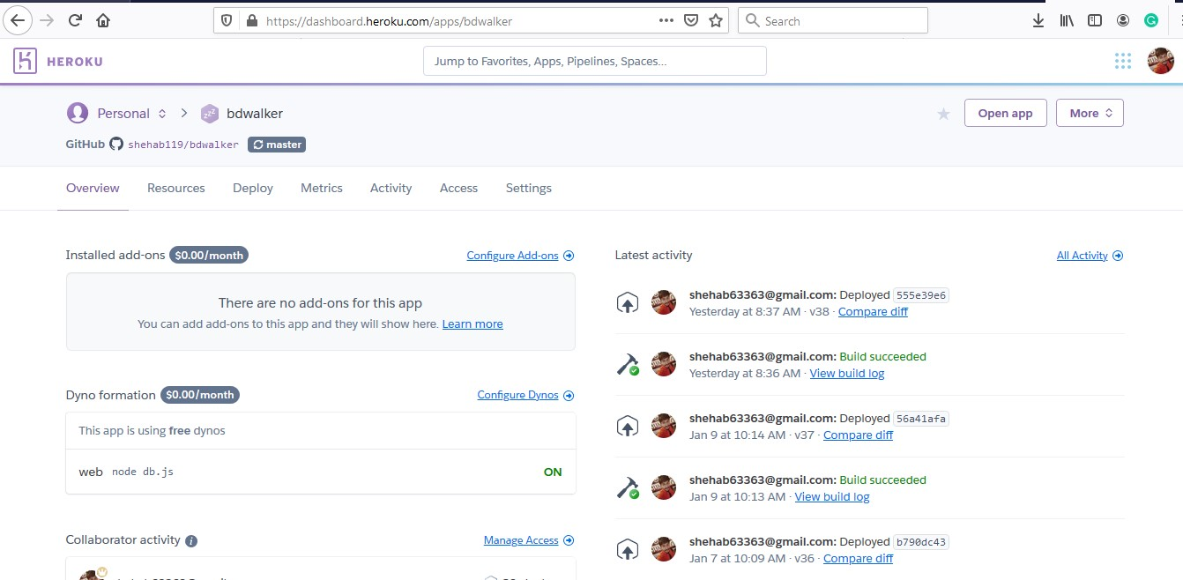

Figure 5.6: Dashboard of my Heroku account

## 5.5 Version Control System (VCS)

I used GitHub as my Version Control System of my project.

You will get the full implementation records step by step on my GitHub Repository:

<https://github.com/shehab119/tourday>.

I started my project implements on Oct 23, 2019, and finished on Jan 9, 2020. In between, I committed 58 times at my project repository.

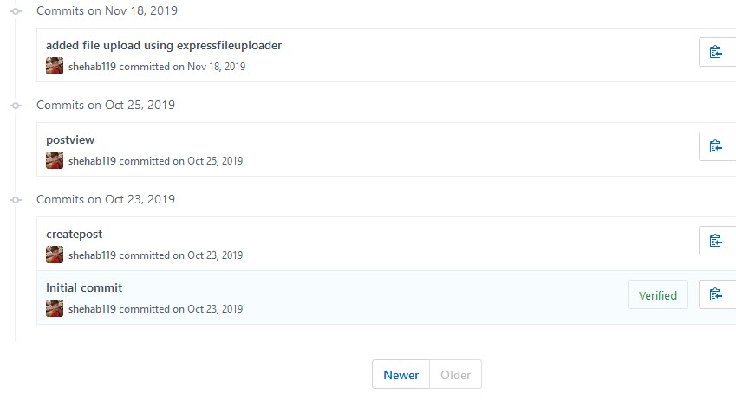

Figure 5.7: First commit on my GitHub repository for bd walker

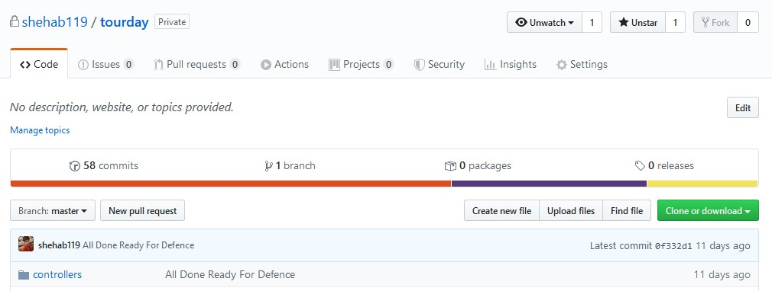

Figure 5.8: Last commit on my GitHub repository for bd walke

## 5.6 Logo Design

By using online photoshop, I designed a few logos for my project [14].



Figure 5.9: BD Walker logo 1



Figure 5.10: BD Walker logo 2



Figure 5.11: BD Walker logo 3

Formore, VisitmyGitHubrepository: <https://github.com/shehab119/BDwalker-Logo>

## 5.7 Features

Each & Every features of my project is given below :

* Authentication
  + Sign-up ( sign-up an account with Live Validation & Email Verification ) .
  + Login as User/Admin (Login With valid username & password ) .
  + Reset Password (Reset your password with valid User & Email Verification ) .
* Profile
  + Modify Profile Information Picture ( modify your Profile Picture, First-Name, LastName, Birthday, Phone Number, Gender & Bio ).
  + View Others Profile with Information ( view others Profile Picture, Username, FirstName, Last-Name, Gender Bio, Posts, Followers & Following ).
* Follow
  + Follow or Un-Follow Others
* Post
  + Create Your Post ( create a post with Google Place Suggestions & CKEditor ) .
  + View Post
  + Modify Post
  + Delete Post
  + View Others Post
  + Add or Remove ’Love - React’ From a post
  + Add or Remove ’Comments’ From a post
  + Report On a Post ( report on a post through Email ) .
* Search a Post ( search a post by Post Title, Place Name, Location Name & Total Cost ).
* Chat ( Global Chatting ).
* Announcement
* Create Announcement by Admin.
* View Announcement by Admin.
* Modify Announcement by Admin.
* Delete Announcement by Admin.
* View Announcement by Users.
* Offer
  + Create Offer by Admin.
  + View Offer by Admin.
  + Modify Offer by Admin.
  + Delete Offer by Admin.
  + View Offer by Users.
  + Booked Offer by Users. ( booked offer by users with Ability & Confirmation ) .
* Guide
  + Create Guide by Admin.
  + View Guide by Admin.
  + Modify Guide by Admin.
  + Delete Guide by Admin.
  + View Guide by Users.
* Account
  + Manage Users Account by Admin ( Ban or Active a user ) .
* Feedback
  + Give Feedback by User ( give feedback through Email ) .
* Contact Us

– Contact Us as a Guest ( contact us via Email ) .

* About – View About Me

## 5.8 System Testing

Testing Each & Every Features Step by Step:

### 5.8.1 Authentication

5.8.1.1 Sign-up

Live Validation Checking.

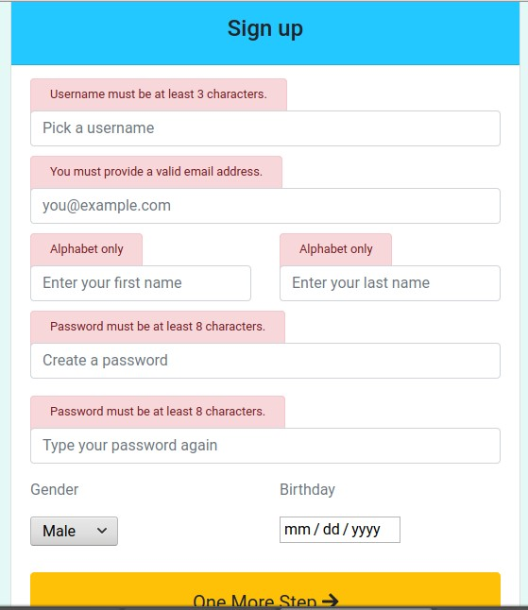

Figure 5.12: Testing live validation

Sign-Up Form Submission Checking.

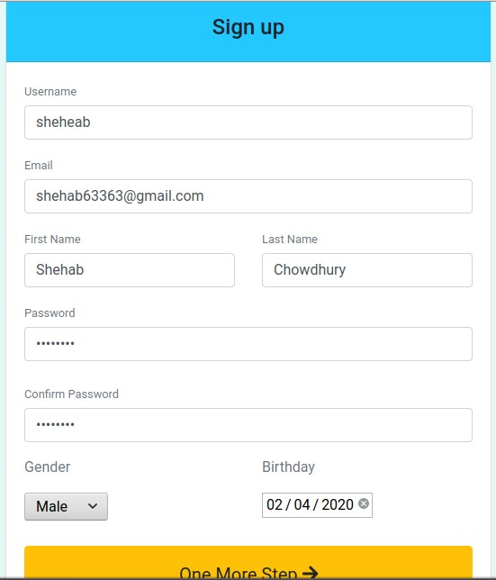

Figure 5.13: Sign-Up form fill up.

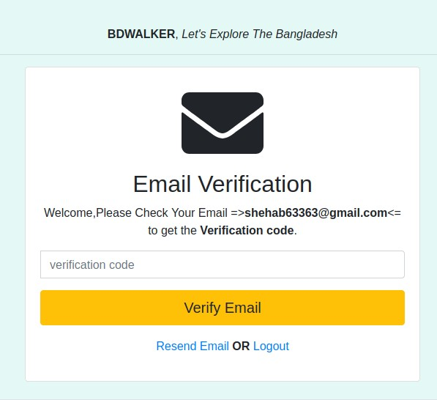

Figure 5.14: Sign-up Form Submitted Successfully

Getting Email Checking.

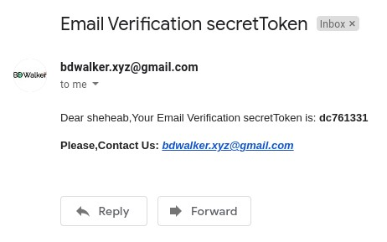

Figure 5.15: Getting email with verification code

Verification Code Checking.

Testing with Wrong Verification Code.

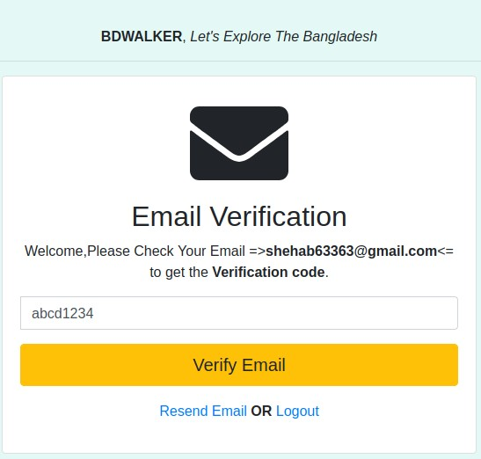

Figure 5.16: Entering wrong verification code

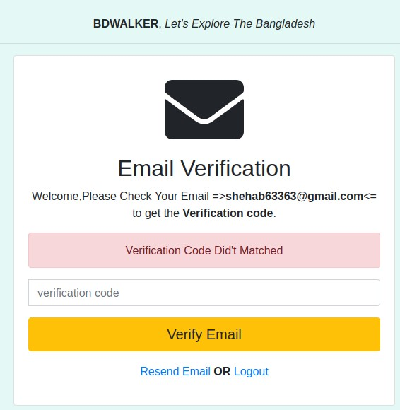

Figure 5.17: Getting errors for wrong verification code

Testing with Correct Verification Code.

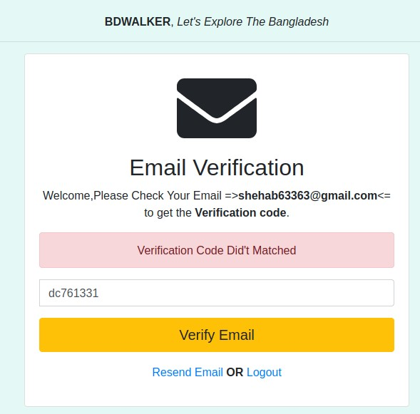

Figure 5.18: Entering correct verification code

Sign Up Successfully Completed.

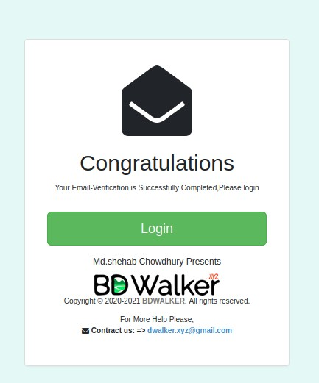

Figure 5.19: Sign-Up successfully completed

5.8.1.2 Login

Trying to Login With Invalid username and Password.

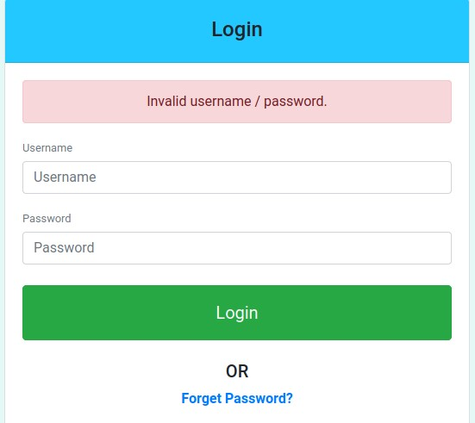

Figure 5.20: Getting errors for invalid username/password

Trying to Login With valid username and Password.

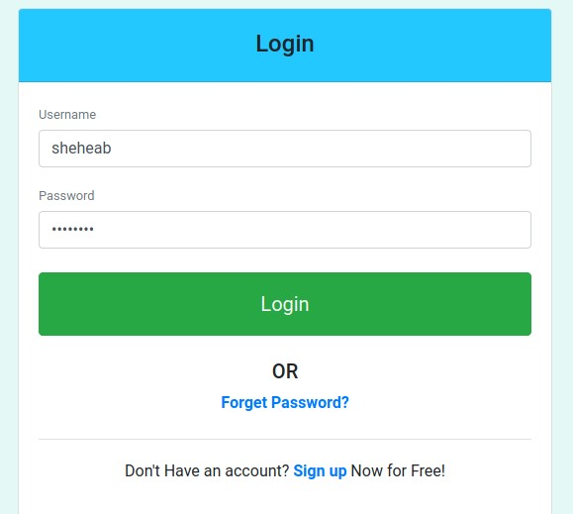

Figure 5.21: Entering correct username & password (User Login)

Logged-in Successfully as User.

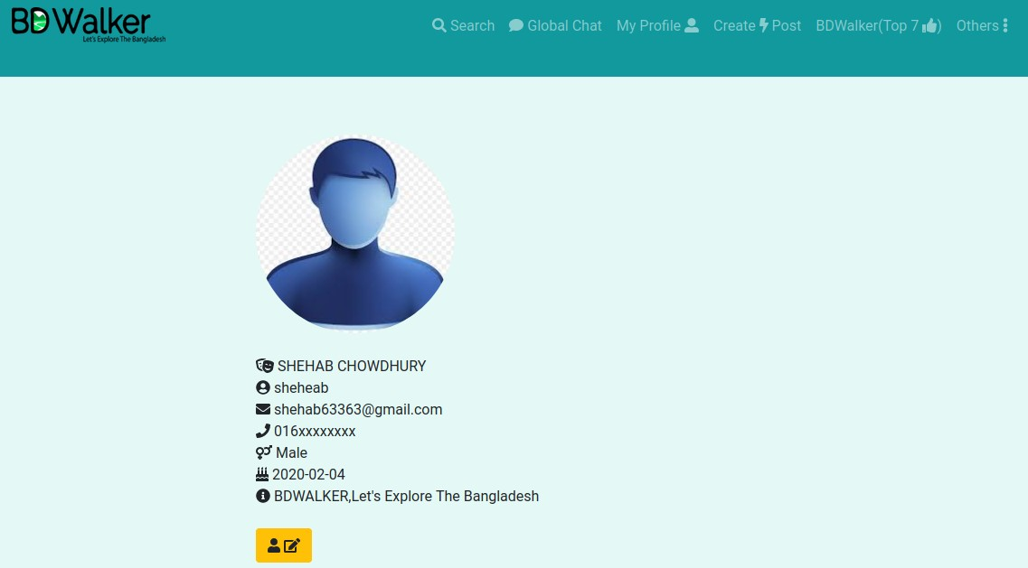

Figure 5.22: User-Dashboard

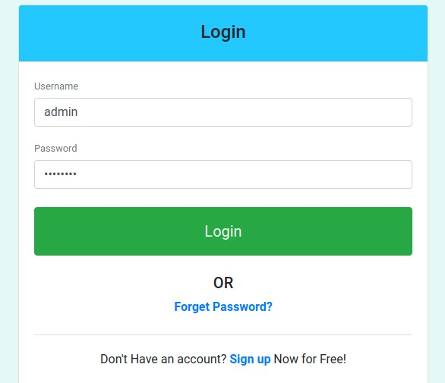

Figure 5.23: Entering correct username & password (Admin Login) Logged-in Successfully as Admin.

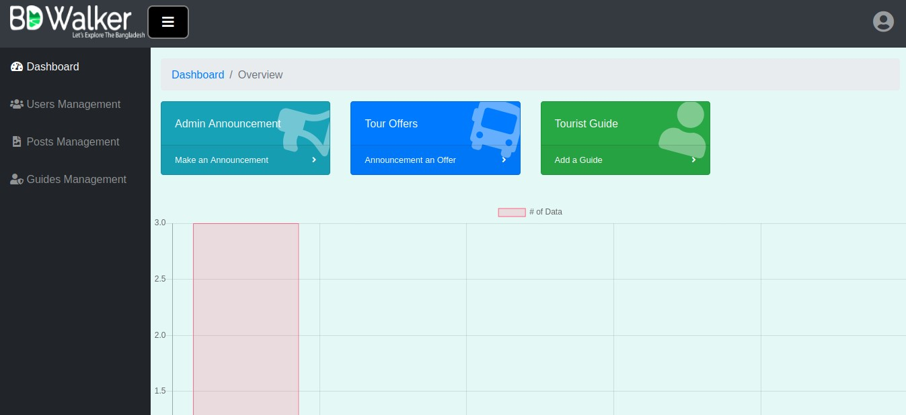

Figure 5.24: Admin-Dashboard

5.8.1.3 Reset Password Reset Password Checking

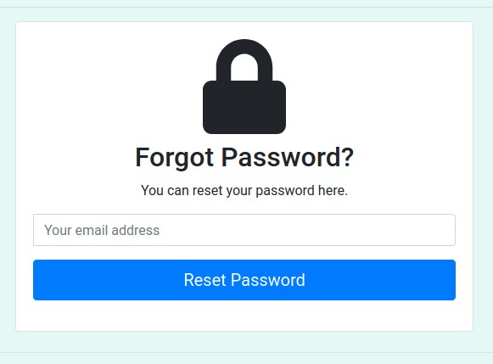

Figure 5.25: Requesting for password reset

Trying to Reset Password With Invalid Email.

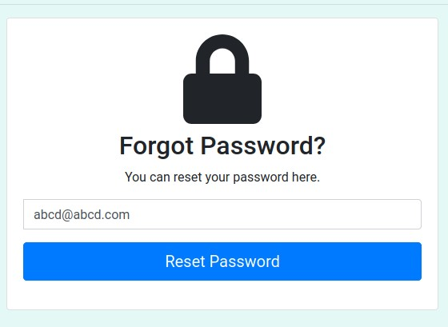

Figure 5.26: Entering invalid email

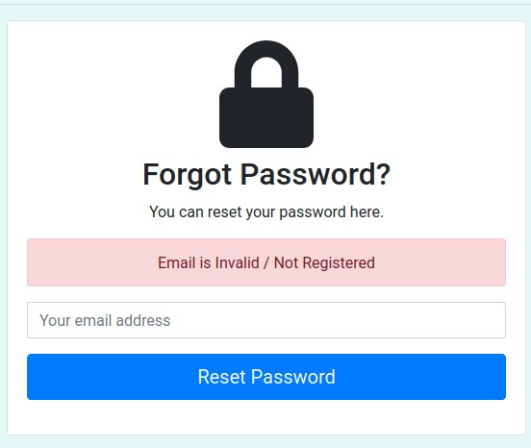

Figure 5.27: Getting errors for invalid email

Trying to Reset Password With valid Email.

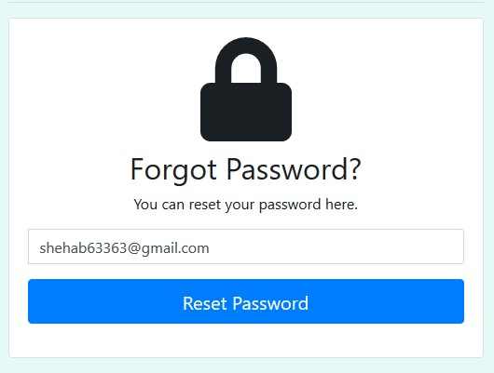

Figure 5.28: Entering valid email

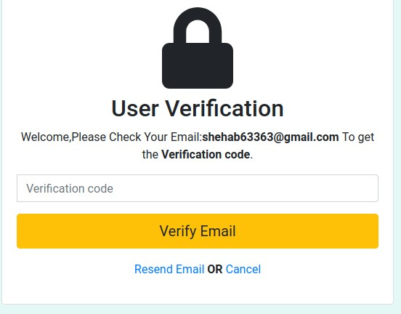

Figure 5.29: Sending user verification code

Getting Email Checking.

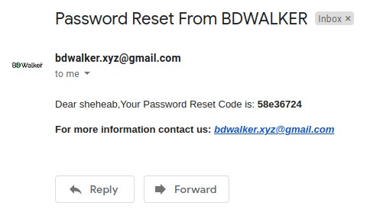

Figure 5.30: Getting email with user verification code

Testing with Correct User Verification Code.

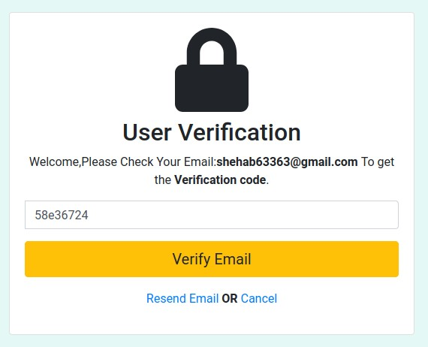

Figure 5.31: Entering correct user verification code

Setting New Password.

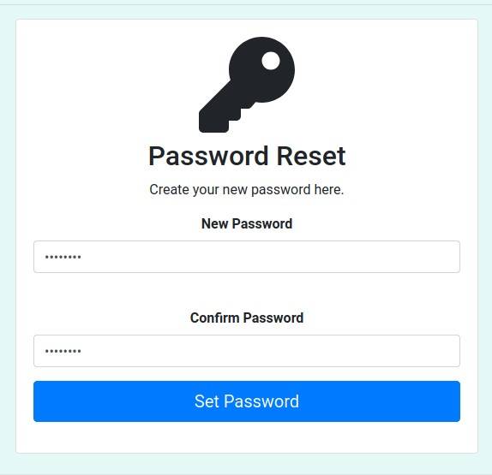

Figure 5.32: Entering new password

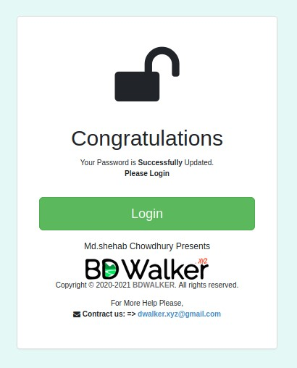

Figure 5.33: Password successfully updated

### 5.8.2 Profile

5.8.2.1 Modify Profile Information Picture Trying to Modify Profile Information.

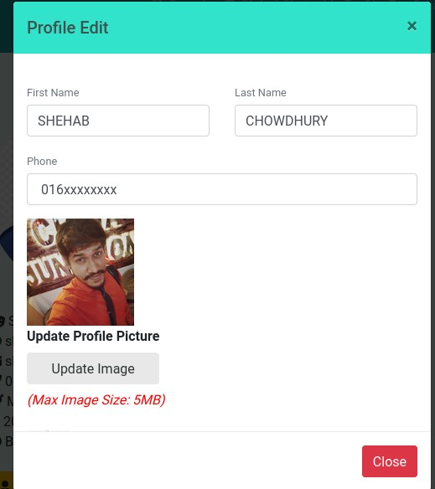

Figure 5.34: Profile picture updating

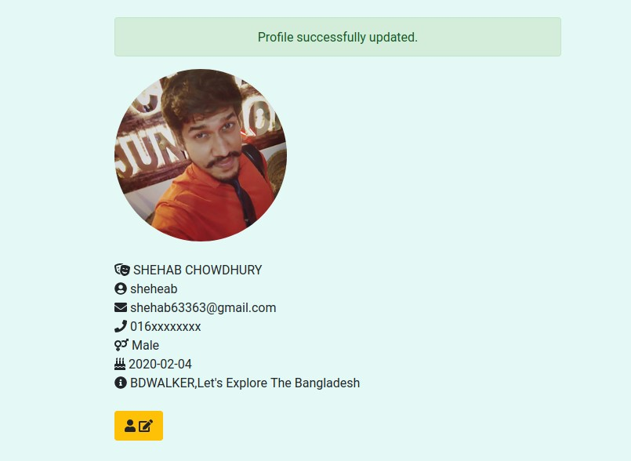

Figure 5.35: Profile picture successfully updated

5.8.2.2 View Others Profile with Information

Viewing Others profile

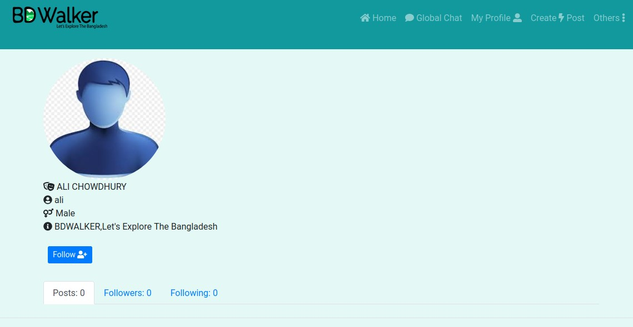

Figure 5.36: Password successfully updated

### 5.8.3 Follow or Un-Follow 5.8.3.1 Follow Trying to Follow a User

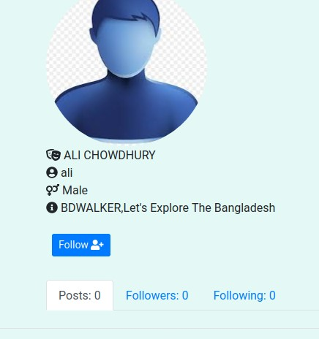

Figure 5.37: Trying to follow a user

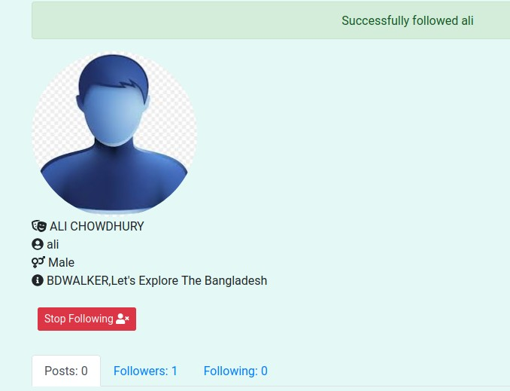

Figure 5.38: Successfully followed a user

5.8.3.2 Un-Follow Trying to Follow a User

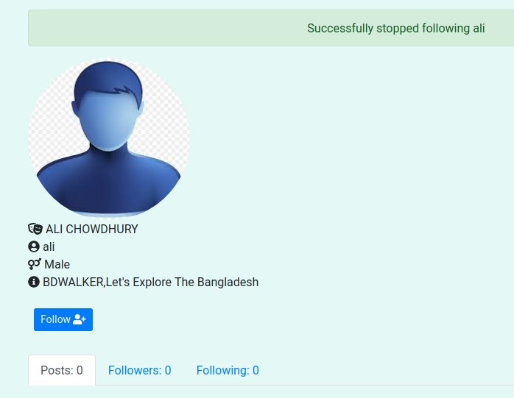

Figure 5.39: Successfully un-followed a user

### 5.8.4 Users Post

5.8.4.1 Create A Post

Trying To Create A Post Using Google-Place-Suggestion API and CK-Editor API

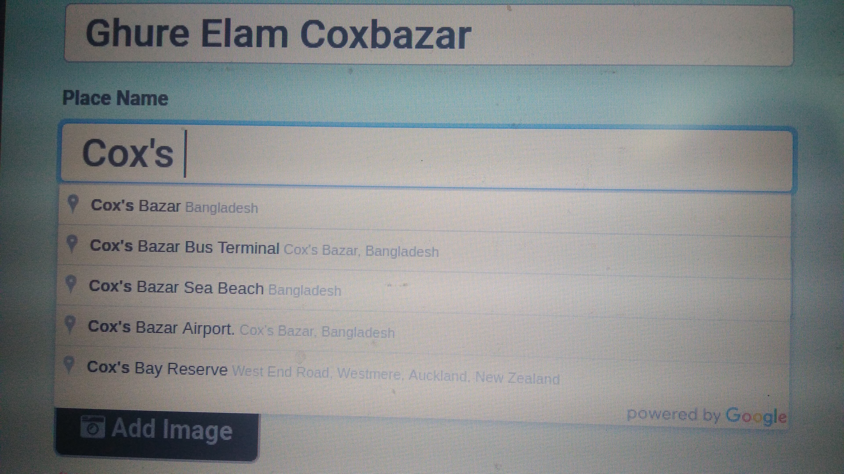

Figure 5.40: Creating a post with Google-Place-Suggestion API

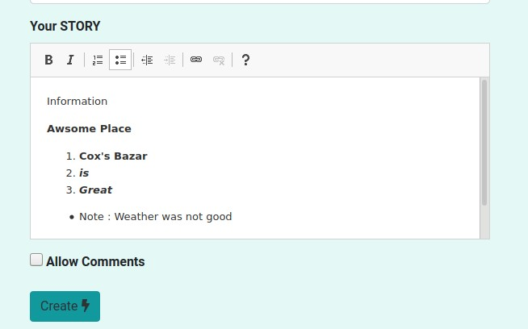

Figure 5.41: Creating a post with CK-Editor API

5.8.4.2 View A Post Trying To View A Post

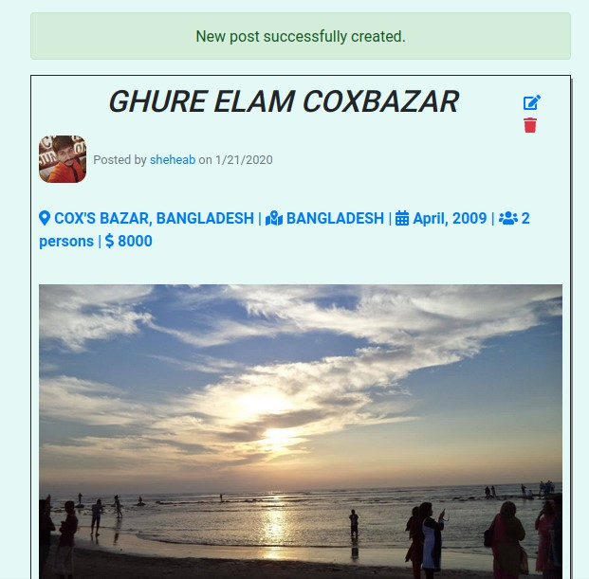

Figure 5.42: Viewed a post successfully

5.8.4.3 Modify A Post Trying To Modify A Post

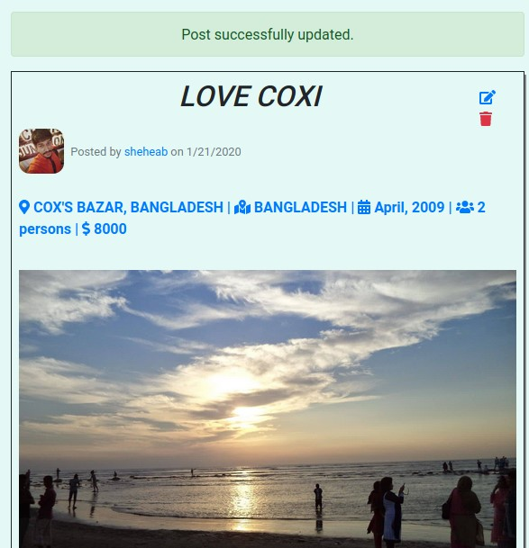

Figure 5.43: Modified a post successfully

5.8.4.4 View Others Post Trying To View Others Post

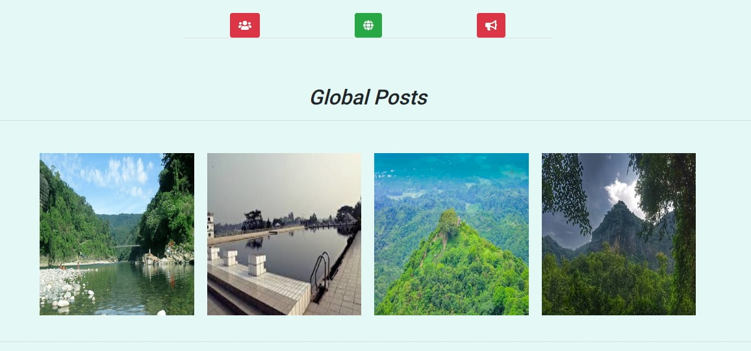

Figure 5.44: Viewed others post successfully

5.8.4.5 Add or Remove ’Love - React’ From a post

Trying To Add ’Love’ On A Post



Figure 5.45: Added love-react on a post Successfully

Trying To Remove ’Love’ From A Post



Figure 5.46: Removed love-react from a post successfully

5.8.4.6 Add or Remove ’Comments’ From a post

Trying To Add ’Comments’ On A Post

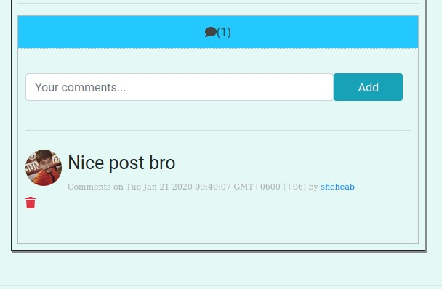

Figure 5.47: Added a comment on a post successfully

Trying To Remove ’Comments’ From A Post

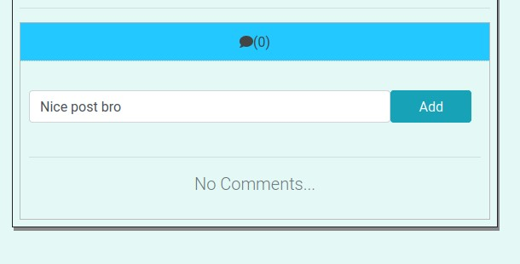

Figure 5.48: Removed a comment from a post successfully

5.8.4.7 Report On a Post Trying To Report On A Post

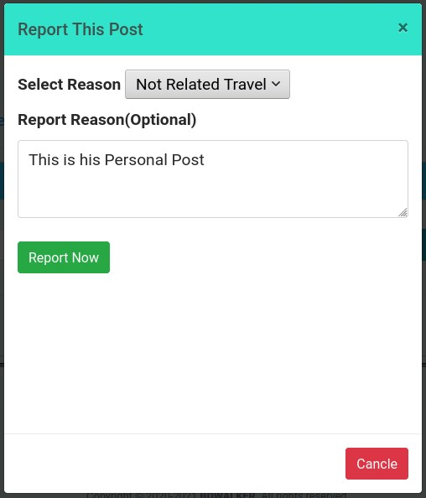

Figure 5.49: Reported on a post successfully

### 5.8.5 Search

5.8.5.1 Search a Post Trying To Search A Post

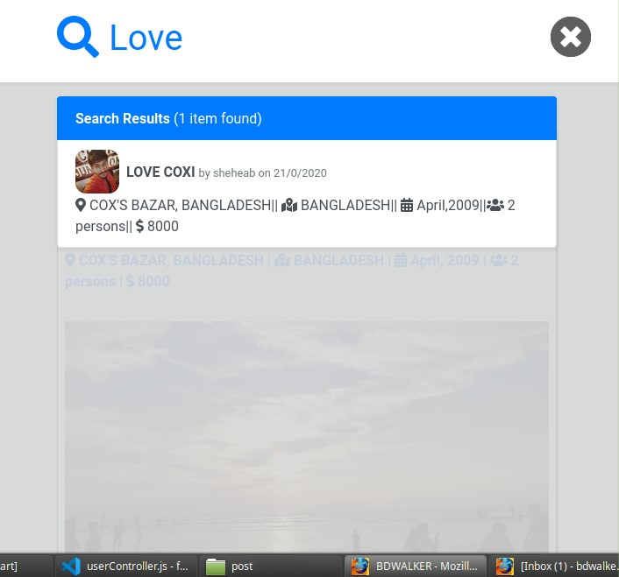

Figure 5.50: Post founded successfully

### 5.8.6 Chat

5.8.6.1 Global Chatting Testing Chat Feature.

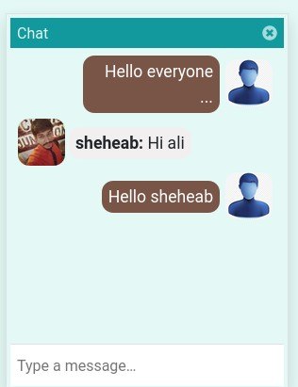

Figure 5.51: Chatting feature is working well (1)

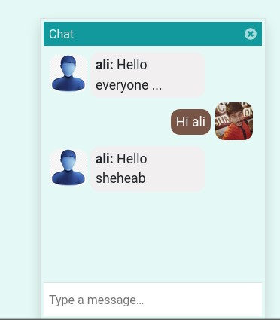

Figure 5.52: Chatting feature is working well (2)

### 5.8.7 Announcement

5.8.7.1 Create An Announcement by Admin

Trying To Create An Announcement

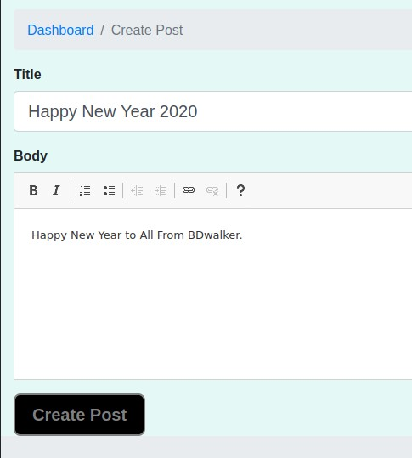

Figure 5.53: Creating an announcement by admin successfully

5.8.7.2 View An Announcement by Admin

Trying To View An Announcement

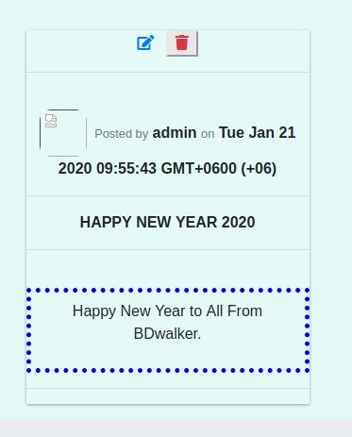

Figure 5.54: Viewing an announcement by admin successfully

5.8.7.3 Modify An Announcement by Admin

Trying To Modify An Announcement

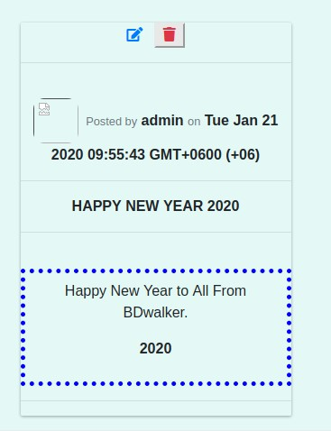

Figure 5.55: Modified an announcement by admin successfully

5.8.7.4 View An Announcement by User

Trying To View An Announcement

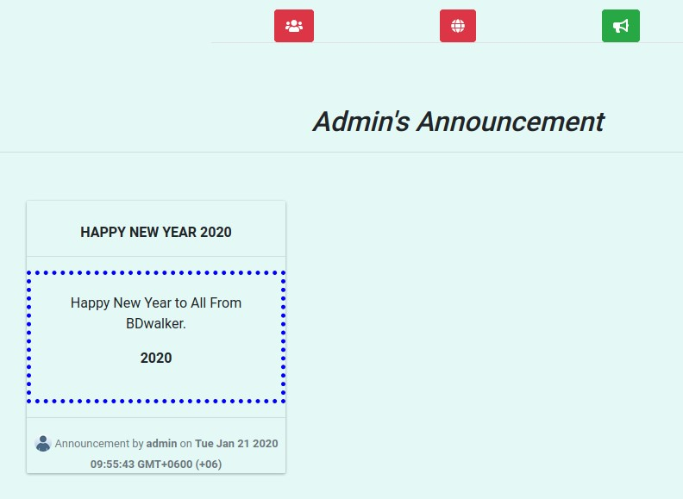

Figure 5.56: Viewing an announcement by user successfully

### 5.8.8 Offer

5.8.8.1 Create An Offer by Admin

Trying To Create An Offer

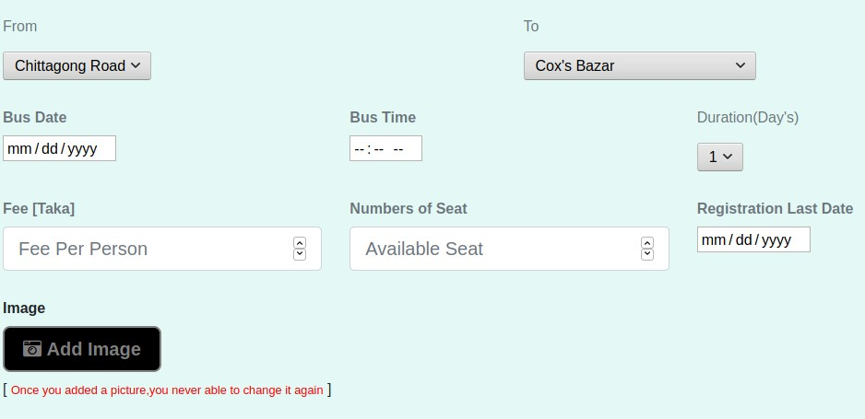

Figure 5.57: Creating an offer by admin

5.8.8.2 View An Offer by Admin

Trying To View An Offer

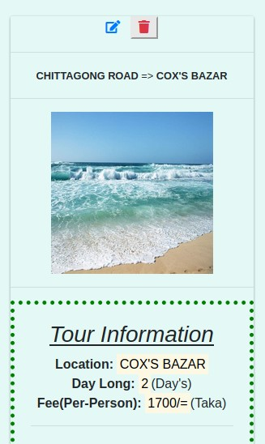

Figure 5.58: viewing an offer by admin successfully

5.8.8.3 View Offer by User Trying To View An Offer by User

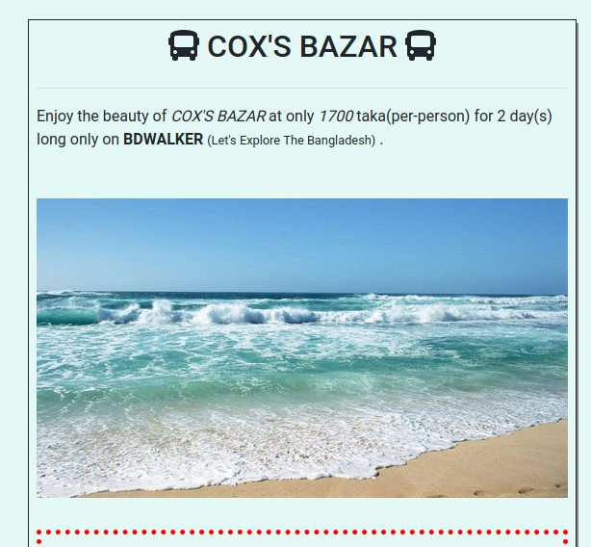

Figure 5.59: Viewing an offer by user successfully

5.8.8.4 Booked Offer by User

Trying To Book An Offer

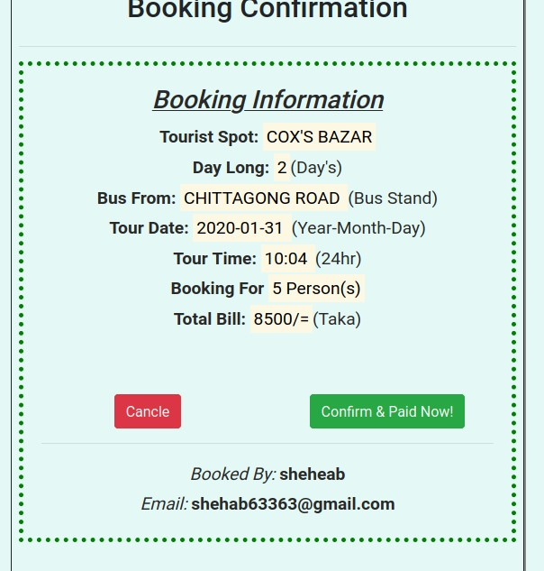

Figure 5.60: Booking an offer

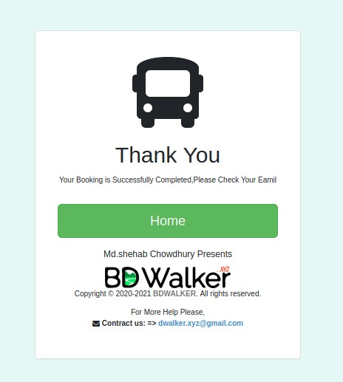

Figure 5.61: Booked an offer successfully

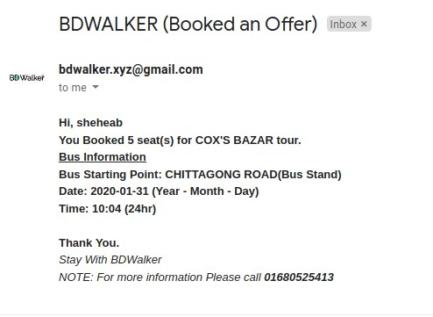

Figure 5.62: Booking Information

### 5.8.9 Guide

5.8.9.1 Create A Guide by Admin

Trying To Create A Guide

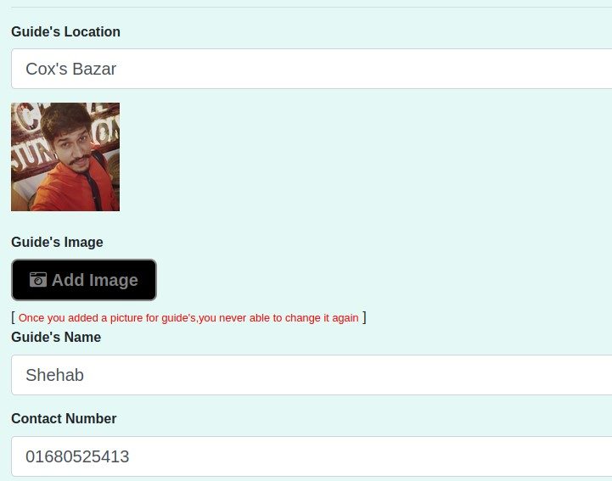

Figure 5.63: Creating A Guide

5.8.9.2 View Guide by Admin

Trying To View A Guide

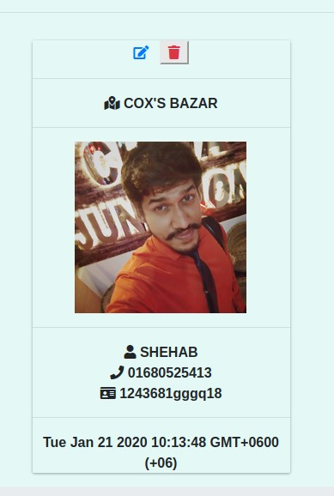

Figure 5.64: Viewing a guide by admin successfully

5.8.9.3 View Guide by User Trying To View A Guide By User

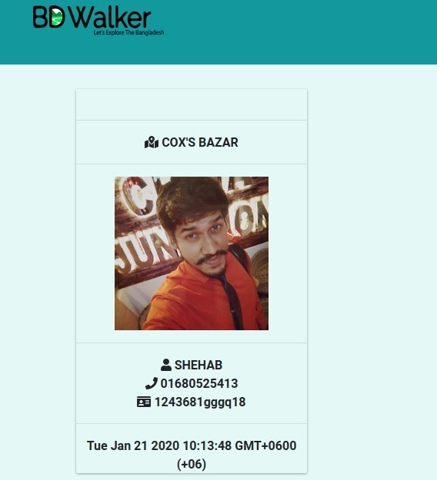

Figure 5.65: Viewing a guide by user successfully

### 5.8.10 Account

5.8.10.1 Manage Users Account by Admin

Trying To Ban A User By Admin

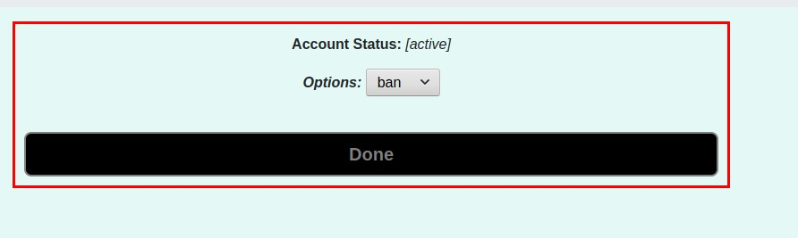

Figure 5.66: Ban a user

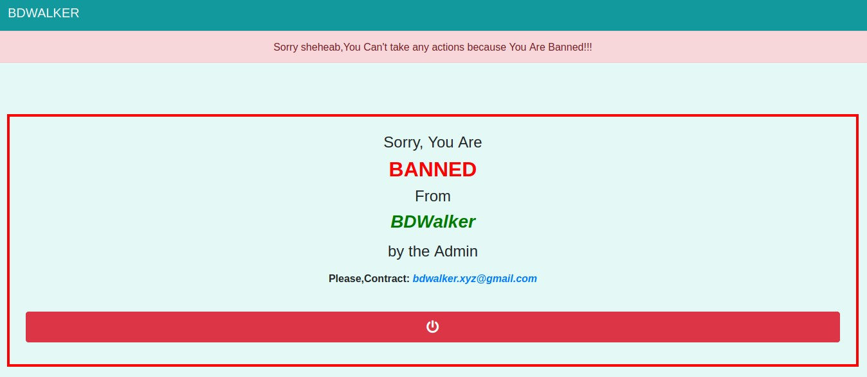

Figure 5.67: User banned successfully

### 5.8.11 Feedback

5.8.11.1 Give Feedback by User

Sending Feedback By User

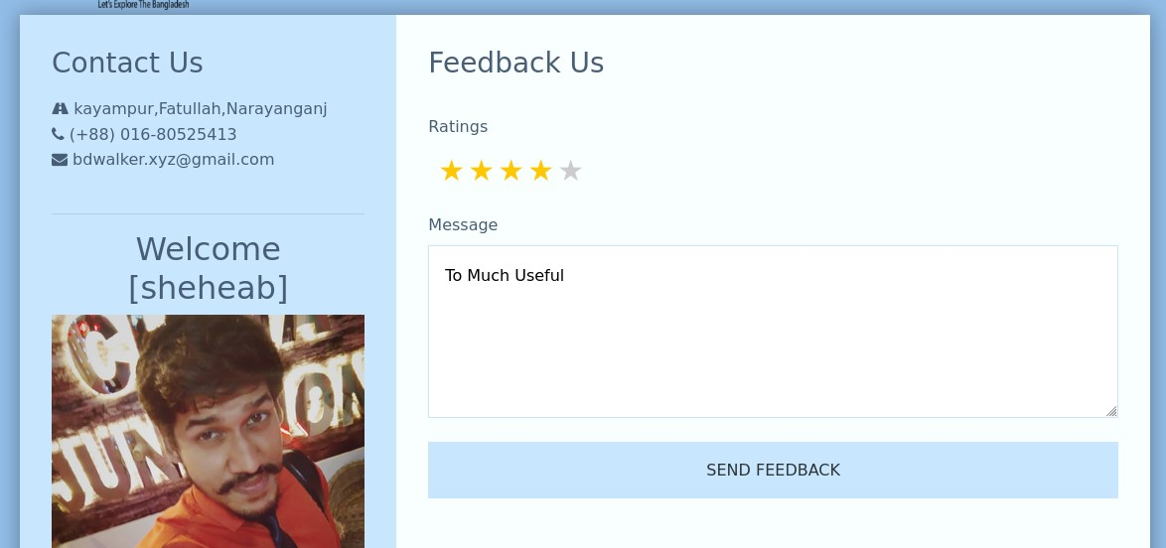

Figure 5.68: Sending Feedback

### 5.8.12 Contact Us

5.8.12.1 Contact Us by Guest

Trying To Contact Via Email

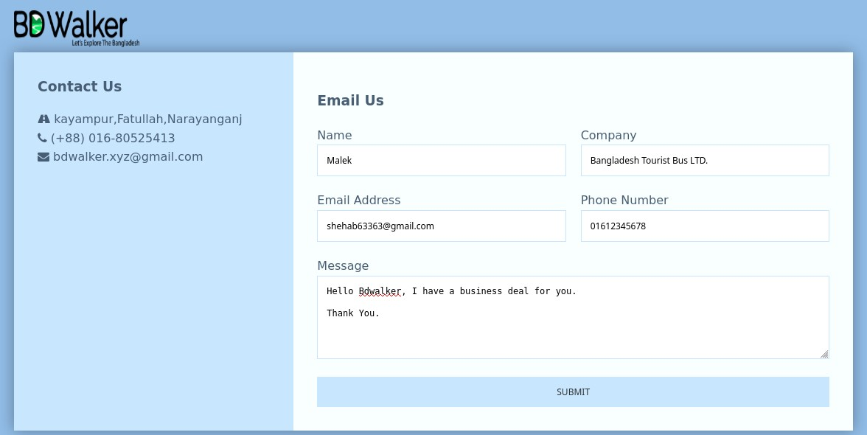

Figure 5.69: Contact-Us

Getting Email From Guest

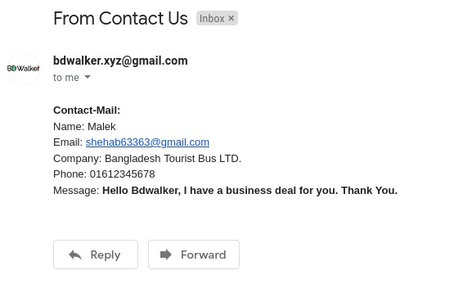

Figure 5.70: Getting email from guest successfully

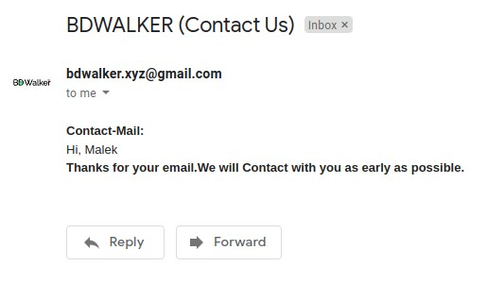

Figure 5.71: Email from bd walker

### 5.8.13 About

5.8.13.1 View About Me

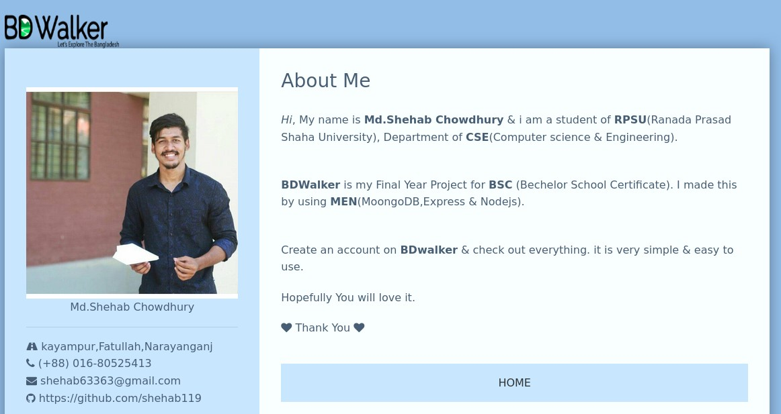

Figure 5.72: About-Me

## 5.9 Limitations

In this section, I will discuss the limitations of ’BDWalker’.

The limitations of ’BDWalker’ are given below :

* The user shall not be able to upload videos and more than one image.
* Notification not available.
* Personal chatting not available.
* Database is limited. 512MB for textual data & 32GB for files.

## 5.10 Alpha Testing & Bug Fixing

This application is Alpha tested. It has tested by over 20 persons. I found few bugs through the test and I fixed them all.

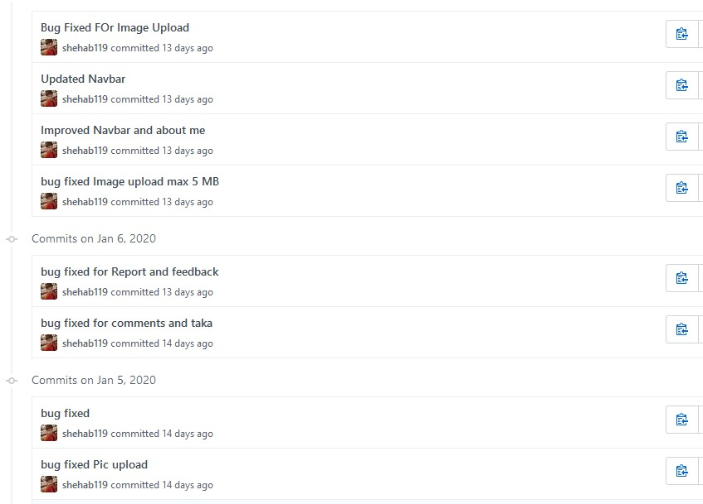

Figure 5.73: Bug Fixed ( Through The Alpha Test )

## 5.11 User’s Feedback & Requirements

After the completed alpha test, the alpha testers gave some requirements and feedback and they

are:

* Need better UI ( User Interface )
* Need Notifications.
* Need personal chatting.
* Need Post Share option.

Chapter 6

# Future Work

In this chapter I will discuss what will be my future work for ’BDWalker’.

1. First of all, I will implement the requirements which are coming from the user’s feedback.

Then I will decrease the limitations of ’BDWalker’.

1. I will add some new features for users like

• **Make A Trip**: By using this feature the user shall be able to announce their early tour information like when and where he/she is going so that other users can joining him/her if they are interested.

I will also add more business systems like

* + **Hotel Offers & Booking System:** In this system the user shall be able to browse hotel offers and booked them, through ’BDwalker’
  + **Restaurants Offers & Reviews System:** In this system the user shall be able to view exciting offers with reviews of a Restaurants.

1. I will release ’BDWalker’ in **Beta** version together with **Reward** offers like ’user who has 100 realistic tourist-related posts, he/she gets 20 taka phone recharge’.
2. I am also planning to make a **Android** app of my project as early as possible.

# References

1. “Biggest Tourist Group in Facebook,**Travelers of Bangladesh**,” [https://www.facebook.com/ groups/mail.tob/](https://www.facebook.com/groups/mail.tob/), accessed: 16-01-2020.
2. “Tourist Booking Site,” <https://nijhoom.com/>, accessed: 16-01-2020.
3. “Official W3C(World Wide Web Consortium),” <https://www.w3.org/>, accessed: 18-01-2020.
4. “The latest version of Bootstrap.” <https://getbootstrap.com/>, accessed: 18-01-2020.
5. “Official NodeJs Site,” <https://nodejs.org/en/>, accessed: 18-01-2020.
6. “Official NPM Site,” <https://www.npmjs.com/>, accessed: 18-01-2020.
7. “Official MongoDB Site,” <https://www.mongodb.com/>, accessed: 18-01-2020.
8. “Official Heroku Site,” <https://www.heroku.com/>, accessed: 18-01-2020.
9. “Official GitHub Site,” <https://www.github.com/>, accessed: 18-01-2020.
10. “Official VS Code Site,” <https://code.visualstudio.com/download>, accessed: 18-01-2020.
11. “Official Font-Awesome Site,” [https://fontawesome.com](https://fontawesome.com/), accessed: 20-01-2020.
12. “Official Mongodb-Atlas Site,” [https://cloud.mongodb.com](https://cloud.mongodb.com/), accessed: 20-01-2020.
13. “Official Cloudinary Site,” <https://cloudinary.com/>, accessed: 20-01-2020.
14. “Official Photopea Site,” <https://www.photopea.com/>, accessed: 20-01-2020.